PSYCHO-SCIENTIFIC FRONTIERS

Selected publications from a variety of subjects of psycho-scientific research. Editor: Rolf Linnemann (Certificated Engineer) * Steinweg 3b * 32108 Bad Salzuflen * Tel. (05222) 6558
Internet: https://www.psygrenz.com
Translator’s email : evak30@optusnet.com.au E-Mail: RoLi@psygrenz.de

Source: Selbstverlag Werner Schiebeler (Wersch-Verlag)

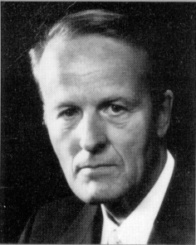

Professor Dr. Ph. D Werner Schiebeler

The public reputation of parapsychology and the opponents of everything paranormal

Werner Schiebeler, Professor, Dr. rer. nat, born in Bremen in 1923, died in 2006. Studied physics in Göttingen and in 1955 graduated from the Max Planck Institute, Göttingen with his thesis on fluid dynamics. From 1955-1965 worked in the electrical industry at SEL AG in Pforzheim, seven years as head of a development department for electronic teletext technology. From 1965 lectured physics and electronics at the then State School of Engineering, now University of Applied Sciences, Ravensburg-Weingarten. Appointed professor in 1971and retired in 1983. In addition to the subjects of natural-science and technology, he also taught para-psychology and para-psycho-physics from 1969 onwards at regular special lectures at the University of Applied Sciences, Ravensburg-Weingarten and continued to do so the ensuing years. The author published numerous articles in journals as well as brochure and four books on various para-psychological topics. In addition, he also released a film about the “Paranormal healing methods in the Philippines” at the Institute of Scientific Films in Göttingen. He received the “Ernesto Bozzano Price” from the Associazione Italiana Scientifica Metaphysica in 1974 and the “1st Swiss Price” from the Swiss Foundation for Parapsychology in 1988.

Preface
The monotonous apostles of denunciation that reject everything occult, amongst other things the recognition of the continued existence of the human spirit beyond the threshold of death, and continue to incessantly disseminate the same phrases either by word of mouth or in writing, are apparently a part of our dualistic world like the kernel inside a nut. The mental state of people that have nothing to say but promote this nothing ad infinitum by dressing in in the same words their whole life, is just as incomprehensible to us as the occult is to them. In their endeavours they are so obviously controlled by their desire to accept nothing occult at all cost that this desire ends in fanaticism. Even theologians mean that their “faith” could lose some of its pertinence if knowledge take its place. But physicists no longer have difficulties with miracles, only theologists have. The following, brilliantly researched report shows how things actually are and what seeking spiritualists can expect if they dare to express themselves publicly.

Bas Salzuflen, February 2005
Life’s memories by W. Schiebeler

During the time after the Second World War, ergo the time that I consciously witnessed as an adult, the term “parapsychology” was equated with the name of Professor Hans Bender (1907 – 1991) in the broader community. Those that mentioned parapsychology meant Bender and vice versa. He was the one that tried to give parapsychology an academic standing in Germany. And so it came to pass that the opinion prevailed in the community that he occupied the only university professorship for parapsychology, but this was in no way correct.

Who was this Hans Bender? He had studied psychology in Bonn and he promoted a PhD thesis titled “psychic automatism” there. He was an assistant at the Psychological Institute at the University of Bonn for a number of years and he dealt with peripheral phenomena of psychology and paranormal apparitions. He also studied medicine and he absolved the national medical examination in Freiburg during the summer of 1939. He later indicated that he had also written a dissertation titled “Die Arbeitskurve unter Pervitin” and during that time and to have absolved the verbal PhD exams under his PhD supervisor Professor Beringer. This was something that he could not verify later and it annoyed him considerably.

After the conquest of France, a Reich University was founded in Strasbourg and an associated professorship for parapsychology and clinical parapsychology established there. Bender was put in charge of it. He held his first lecture during the summer semester in 1942 and he was supposed to teach faculty based psychology there. But he undertook some serious parapsychological studies after that.

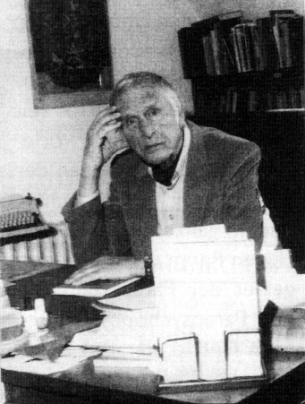

Bender at his desk in his institute.

The Reich University, Strasbourg was naturally dissolved after the war was over and after a short stint at an American detention camp, he and his family (he had a wife and children by then) moved to his hometown Freiburg in Breisgau. In 1946 he received a teaching assignment within the faculty of psychology at the University of Freiburg. This gave him the opportunity to do some extensive research into parapsychology. From then on until his death, his main areas of interest were the phenomenon of dowsing rods, dreams, healers, astrology, precognition, psychokinesis, and particularly hauntings. The latter investigations were to a considerable degree responsible for his renown in the public arena. His friends and his enemies called him the ghost-professor.

Something Bender had no interest in whatsoever were the physical phenomena produced by mediumism, materialisation apparitions and life after death. All paranormal apparitions were caused by the human psyche as far as he publicly admitted and they arose from the risers of the subconscious. This concept is called animistic in contrast to the spiritistic concept that asserts that a lot of apparitions stem from the influence of the deceased.

Professor Bender once told me in a private conversation:

“I have to agree with you that the physical phenomena are of particular importance, but one must not behave like this Dr. Gerloff and visit Einer Nielsen in order to have breakfast with his grandmother.”

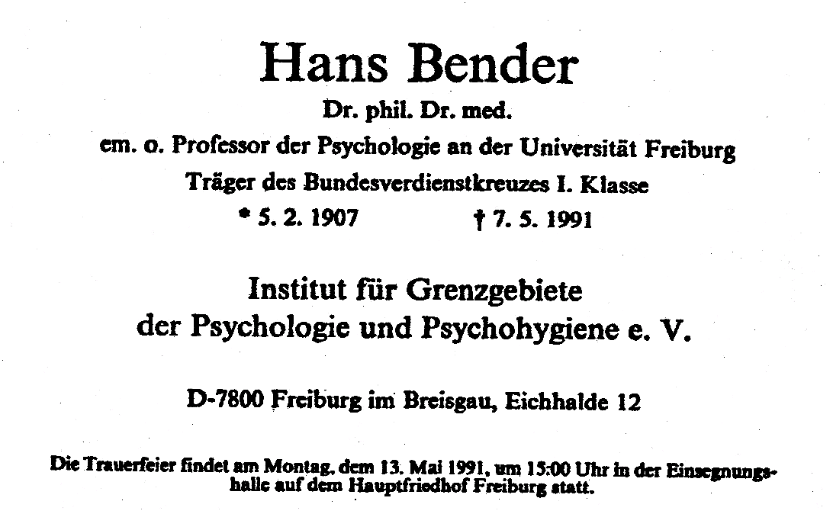

This is why he never visited Einer Nielsen (1894 – 1965) in Copenhagen, the most eminent European materialisation medium of the 20th century . Dr. Gerloff on the other hand tested and investigate Nielsen a number of times and wrote books about him.

Bender utilised some special energy for the construction and setting up of his own institute. He collected the money for it, bought a piece of land at the Eichhalde in Freiburg and managed to inaugurate the institute, he called it “Institut für Grenzgebiete der Psychologie and Psychohygiene”, in 1950. This institute, with Bender as its manager, was however not affiliated with the university, it was a purely private affair.

As an associated professor at the University of Freiburg, Bender received a teaching post for “Psychologie und Grenzgebiete der Psychologie” in 1954. This associated professorship was converted into a full professorship in 1966 and Bender was its director until his retirement in 1975. He was from then on, just the director of the private Institut für Grenzgebiete der Psychologie and Psychohygiene at the Eichhalde.
I contacted Professor Bender for the first time in March 1954 to ask him whether his institute published a journal. But this was then not yet the case. A loose connection with him has not been severed since.

In 1961 I began to prepare experiments in regards to the psychokinetic influence during random processes. This refers to the mental, spiritual influence on processes of coincidence. A so-called random generator is for instance the known six-sided dice with numbers 1 to 6. Attempts to influence the process of throwing a dice has been undertaken successfully in the USA by the then well-known biologist and parapsychologist Professor Joseph B. Rhine (1895 – 1980) with numerous test subjects. Attempts were made, through purely mental effort, to preferably throw the number 5 for instance, that is to say, to go beyond the probability of 1/6. This actually succeeded with some of the test subjects. This made Rhine very famous in relevant circles.

In the 50s, I professionally developed an electronic cube for telex encryption purposes that produced random numbers from zero to 31 by utilising the radioactive decay of Caesium. As this apparatus was produced for military purposes and used by NATO, I constructed a smaller electronic cube for private purposes, one that didn’t utilise radioactivity and therefore could only randomly produce the numbers zero or 1. The cube utilised a not too frequency-constant multi vibrator whose vibration frequency was prompted to produce even or odd numbers at intervals. I used this small apparatus to experiment with psychic and non-psychic people to see whether they could mentally influence the random number distribution. I reported these experiments to Professor Bender, because he planned to carry out similar attempts at his institute and therefore showed an interest for my test arrangement.

My attempts unfortunately remained unsuccessful, because I could not find sufficient numbers of suitable test subjects or find the time to carry out this massive series of tests. Whether Bender’s Institute succeeded escapes my knowledge. They apparently succeeded in the USA.

As Bender became publicly extremely well-known, the opponents of everything paranormal had their sight set mainly on him. They also shone a light on his past to see whether they could find a skeleton in his cupboard. – And they found it. They couldn’t actually find his medical PhD thesis.

The German magazine Der Stern, issue 10/1977 published the following article:

“The doctor from the hereafter?
The spook professor Hand Bender from Freiburg must deal with a new enigma:
Where does he get his second doctor title from?”

This report asserts with tongue in cheek that no medical dissertation or doctoral certificate could be found in regards to Bender. The reports ends with:

“The fact that Bender is also listed as a doctor of medicine and possible isn’t one does actually verify: The paranormal does really exist! The supporters of the supernatural will rub their hands together, because spook, witchcraft and miracles are therefore not figments of imagination from mankind’s dark periods, but facts. One is finally able here to grasp the ungraspable, even if doubters impertinently assert: It cannot be grasped!”

This was extraordinarily embarrassing for Bender and I also found it largely incomprehensible. If he had actually graduated, he would have carefully saved his graduation papers and also made sure that his PhD thesis was duly registered at all German universities or published in newspapers. His PhD supervisor should also have ensured that this was happening. He did indeed not graduate in Köningsberg, where everything was lost by the end of the war, but in Freiburg where everything remained intact.
Bender was inherently extremely unreliable. He didn’t keep his promises and he was either late or didn’t turn up for appointments. I have experienced this personally. His biographer and part-time assistant Elmar Gruber reports that Bender turned up notoriously late for his lectures at the university. But to deal with the graduation papers so slovenly is incredible, if they had actually existed in the first place.

Conclusion: He could not prove his medical graduation and the public prosecutor started a preliminary investigation against him for unauthorised use of a title. In this plight he found a benevolent professor that allowed him to enter a hastily produced dissertation and fast track his doctoral examination. This made him a real doctor of medicine.

Bender’s opponents and the opponents of everything paranormal came (and still come) from the ranks of: The judiciary, the police, the medical fraternity and evangelical theology. Even though Bender says nothing at all about ghosts or the survival after death, ergo remains completely earthbound, they still saw his research as an attack on their atheistic and materialistic philosophy, even if they would publicly reject the very idea. They agitated against him with a fanaticism that is usually reserved for extreme sects. They suggested that he wanted to lead them back to the sinister Dark Ages and prepare a path for a new inquisition and the burning of witches at the stake.

One of Bender’s main antagonist was a Dr. jur. Wolf Wimmer. He was a District Attorney and later a presiding judge at the District Court in Mannheim. He still held this position in 1993. I do not know whether he is still in office or alive. His point of attack is easily discerned from an article in the Deutschen Ärtzeblatt Heft 10/1974. This work is titled “Eine andere Wirklichkeit? – Vom Unfug der Parapsychologie.” It says in its opening credits:

“In conjunction with a supporting letter by the world-renowned coroner Otto Prokop, who always stood up against any occult ‘obfuscation’ of the sciences, this article mentions the dangers of a new belief in witches and miracles. The development of a religiously coloured new occultism of many varieties is much further advanced in the United States and it is feared that Europe will soon ‘follow suit’. There are lots of signs for this. It isn’t just the swindles perpetrated en masse on the faithful in connection with the occult to fool them that is particularly dangerous. The danger lays rather in parapsychology’s claim to be a science, one that justifies an old, at times murderous mania in a modern way.”

Everything paranormal, including acupuncture, is explained away as trickery and deception in this article and culminates in the statement (Page 738):

“Millions have already been driven to their death by something disguised as a miracle faith once before. Similar psychic epidemics can be repeated at any time. By the crimes of the witch hunts, history’s warning signs, we can recognise that nothing remains without consequences even in science and even if it’s the greatest nonsense, some the image below depicts. Common sense actually turns into nonsense and a scourge. All insights therefore have the serious duty to become an immunisation through enlightenment and warning. The present cultural regression is hair-raising enough as it is. A reignited magical madness is the last thing this tormented century could possibly bear. – And if we look at some of the products of Psi-research we are rather inclined to accept villainousness as a folly or a simple mental disorder, what is rather more to the point.”

Also in 1974, this Dr. Wimmer published a series of articles in the journal Metall (The Trade Union Metall) that stretched across seven articles (Issues 4/74 to 10/74) under the title “Parapsychology – Magic and Mass Hysteria”.

These contained sub-headlines:

“Superstition – also with professors. – Those that print delusional stories are accomplices. – Desk perpetrators fire up the cauldron. – Do not listen to pseudo pundits. – Fight the dark side. – Taxes for phantasms. – Books by the mentally insane. – Nonsense is contagious. – Soul journeys to the witches sabbath. – Count Dracula at the door? – Flying around like witches? – Lucrative dumbing down of the public. – Book-writing mass murderers.

We now know that parapsychology is nothing new, that it only continues with what we are already confronted with, with the witches and demon doctrines by so-called scholastics of occult studies of the Middle Ages. The results are known: Mass hysteria lead to mass murder. Millions of innocent women, children and old men died a horrible death. Millions suffer from delusions. But why care about such knickknacks? Most think that we have better things to do. But standing offside can turn out dangerous. We immediately recognise how important these things are when we hear that the above mentioned Professor Bender was considered to be the most prominent Parapsychologist in all of Germany. Occultists that once again believe in ‘clairvoyance’, ‘thought transference’, ‘prophecies’, ‘hauntings’, ‘magic and similar medieval delusions base their beliefs on his ‘research’ and his ‘scientific evidence’. And they count in the millions.”

Dr. Wimmer published similar articles in numerous newspapers and journals. In 1976, he even published a book with the East Berlin (GDR) forensic pathologist Professor Dr. med. Otto Prokop titled "Der moderne Okkultismus - Parapsychologie und Paramedizin - Magie und Wissenschaft im 20. Jahrhundert". The content of this book is drafted in a similar fashion to the already mentioned article by Wimmer. Parapsychology is branded an anus-science and a hybrid between superstition and pseudo-science.

The preface mentions amongst other things:

“The book on hand represents a protest and an accusation, directed against the activities of parapsychologists and paramedicine that have completely misinformed the general public for years with the support of a certain section of the press. – Fairness does have its limits when it comes to psycho-hygiene.”

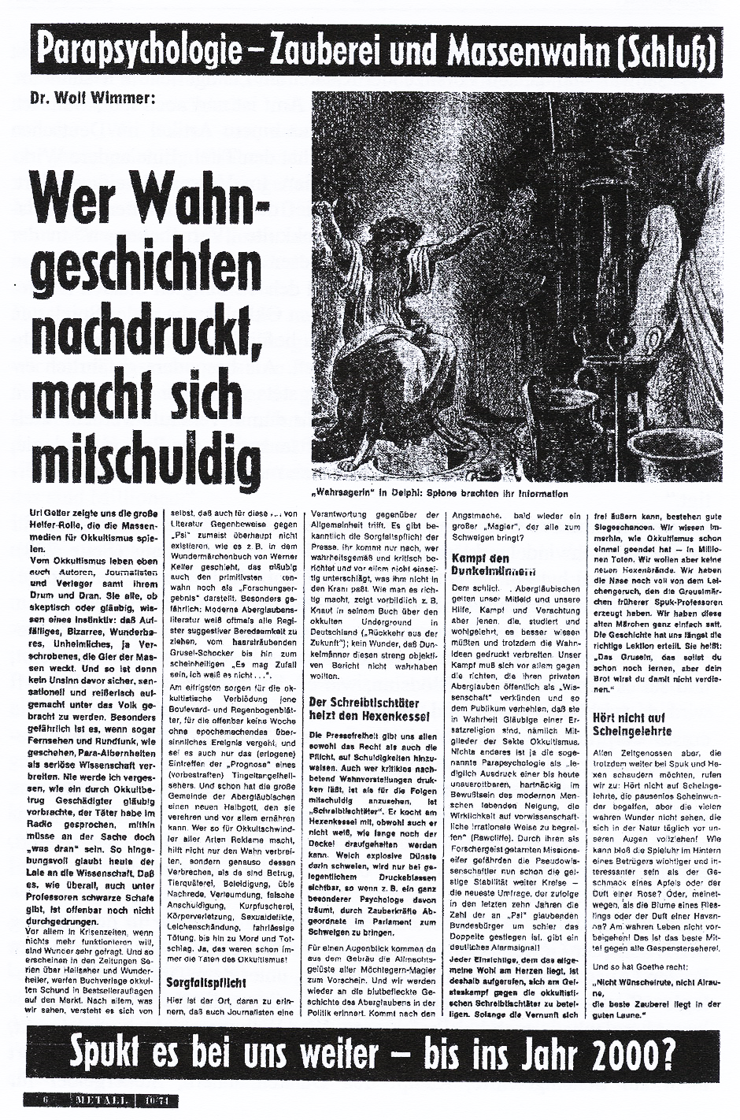
Another fanatical opponent of Professor Bender and parapsychology was and is the former Senior Criminal Director of Bremen, Dr. Herbert Schäfer. He coined the phrase “occult culprit” and amongst other things, wrote a book: “Der kriminelle Aberglauben in der Gegenwart”. I am mentioned twice in this book, however not by name. Besides, Schäfer was also the publisher of a series of paperback for criminalists titled: “Grundlagen der Kriminalistik”. He had decided to give Professor Bender the final blow. He called him a “psytiot” (=psychopath and idiot). He said to colleagues (according to a newspaper report):

“I use every available means to topple him.”

And the following opportunity arose: A sensational case of haunting took place in 1965 in a delicatessen and porcelain shop owned by the couple Surowitz in the Schwyzer-Scholl-Strasse. A 14 years old apprentice by the name of Heiner Scholz was working there at that time. Destructive processes took place in the shop from a specific point in time. Without obvious reason, jars of preserves fell from shelves, a valuable coffee pot jumped over other items of porcelain and crockery flew through the air. The delivery driver Manfred Janssen experienced for instance how crockery fell from shelves in the basement and how stacked boxes filled with full bottles tipped towards him whilst he was making a delivery. He was lucky that he wasn’t hurt.

All of these incidents, stretching over weeks, only happened when the apprentice Heiner Scholz was in the shop or stood nearby. But one could definitely observe that his hands did not play a part.

The police and the fire brigade were engaged to investigate these happenings. Such action also took place whilst they were present, but they could not find the cause for this.

These happenings only stopped after the apprentice left his job, he underwent psychiatric treatment for a while and was then examined more closely by Professor Bender in his institute in Freiburg. Crockery didn’t fly through the air there, because there was none there, but some very impressive paranormal processes ensued.

Dr. Schäfer tried to give Professor Bender the coup de grass 13 years later. During the spring of 1978, he first demanded a written waiver from the shop owner Surowitz for the damage that happened during the haunting. Surowitz said that he made no demands on Heiner Scholz. But Schäfer insisted on a written waiver. He then dropped a bomb. Heiner Scholz suddenly declared that he had produced all these happening himself and he gave detailed accounts of them. But particularly how he had duped the simple-minded Professor Bender.

All of this was published in all German newspapers and depicted in detail on television.

But it was immediately obvious to every halfway reasonable person that this “confession” was fictitious because these events could not have taken place they way Heiner Scholz had described them. Mrs. Herta Hansen, the wife of a doctor in Bremen, made an effort to thoroughly question all the witnesses at that time: The couple Surowitz, the driver of the delivery van, the officials from the police and the fire brigade and the mother of Heiner Scholz, Mrs. Ilse Kislath and all of them said that Heiner Scholz’s assertions were fictitious.

Professor Bender then published the necessary counter claims in newspapers and journals. I cannot decide whether this could neutralise the reports given by Dr. Schäfer.

Dr. Schäfer also tried this in another case in 1974 about a television broadcast by Uri Geller that caused quite a stir, namely by getting some of the participants to confess through intimidations that they had caused these happenings themselves. He did however achieve nothing because the participants refused to “confess” to anything.

Dr. Schäfer retired in 1986 and he has been working as an attorney in Bremen since then. He wrote another book in 1994 titled “Poltergeister und Professoren”. In this book he also explained all ghostly apparitions in his own way, namely as practical jokes perpetrated by juveniles. In regards to Professor Bender, he talks about the sad ballad of a pitiable man from the Eichhalde in Freiburg, the Primus inter pares.

It is beyond doubt that plethora of swindlers and charlatans ply their trade in the esoteric arena. Also, those that give themselves the ornamental title “parapsychologist”. But this is what fanatical opponents use to altogether demonise everything paranormal and to declare that it is criminal superstition or conscious deception. But the serious parapsychological researchers neither call themselves insane or swindlers. Professor Bender in the other hand described his standpoint as follows:

“What is required is a positive criticism of superstitions based on effective elucidation and prevention of damages, a willingness to impartially investigate the non-sanctioned fringe phenomena of our experiences, to admit the confirmed and to oppose all fantastic imaginations and expectations” (expressed in regards to Mrs. Herta Hansen from Bremen).

The next fierce opponent of everything paranormal is a woman, namely Professor Dr. med. Irmgard Oepen, born on the 25th of February 1929. She qualified as a professor at the University of Magdeburg in the subject Forensic Serology and Forensic Anthropology. In 1974 she was nominated to the position of professor in this subject at the Institute for Forensic Medicine (established post H2). Her main work dealt with paternity cases.

Next to this, ergo privately, she was the President of the GWUP, the “Gesellschaft zur wissenschaftlichen Untersuchung von Parawissenschaften e. V.” (Society for scientific research into the para-sciences). This society publishes the journal “Der Skeptiker” (The Sceptic) wherein everything paranormal is criticised at absurdum, ergo wherein everything is explained as trickery and swindle.

Mrs. Oepen personally talks very aggressively and hatefully against all healing methods outside of school taught medicine in her lectures and publications, ergo against neural therapy, homeopathy, iris diagnostics, spirit healing and all other alternative healing methods, including earth rays (negative rays emitted from below ground) and dowsing. As she attacks these doctors in a hostile and belittling fashion in her public lectures, they react accordingly and have nothing good to say about Mrs. Professor Oepen.

In November 1985, Professor Oepen held a lecture at the Ärtzlichen Verein Hamburg within its framework of “Scientific evenings” about “Outsider methods within medical diagnostic and therapy”. A medically trained listener and reporter wrote a lengthy treatise about this evening, saying amongst other things:

“The tone of execution was not objective – explaining the subject at hand – the way one expects it from a scientific exposition by a qualified university professor, it was rather prejudiced, aggressive, degrading and mixed with contempt and glee. It was at times unclear whether the rage of the presenter was mainly directed at naturopaths she often talked about, or against doctors that allowed themselves to also show an interest in methods that are outside school taught medicine.”

Based on these statements, a doctor from Hamburg, Dr. Med. Hahn-Godfrov, directed severe accusations against Mrs. Professor Oepen who in turn sued in court in two instances. The final judgment by the Higher Regional Court, Hamburg on the 18th of December 1986 was proven to be true as reported in the following report of the facts:

“Mrs. Professor Oepen was only active as a paper doctor, she was an unrealistic theorist, possessed only reading knowledge and could only present paper knowledge.”

And may a value judgment be permitted:

“Mrs. Professor Dr. Oepen was incompetent, disseminated a deceptive impression of science or juristic standing. Her explanation in her works and lectures were unbalanced, aggressive, unfair and unfriendly and she represented a ‘Cuckoo’s egg in the nest of forensic medicine’. – Her works were not a subject of forensic medicine, but her private hobby.

To have to represent Mrs. Oepen was an embarrassment for university medicine, embarrassing also for the Institute of Forensic Medicine of the Marburg University and the Federal Medical Association, personal dealings and conversations with Mrs. Oepen were rather awkward.

I encountered her on the 26th of March 1993 during a television program about Spiritual Healing on Südwest 3 (Nachtcafe). She attacked me and I retaliated by citing the judgment of the Higher Regional Court. An intense exchange of blows ensued, one that the moderator Wieland Bakes wasn’t too pleased about. He brought an end to it with the words:

“I decided the rules of the game here.”

This scene was – as expected – cut from the recording by him, so that it wasn’t televised. But I had recorded it with a small tape recorder and I played it back during two of my lectures later as an example of how television moderators manipulate their programs.

Another opponent of everything paranormal was the science journalist, neurologist and psychiatrist Professor Dr. med. Hoimar von Ditfurth (died 1989). He was the moderator of the ZDF-Science-Journal “Querschnitt”. This program gave him the opportunity to go into battle against everything he considered superstition. This included amongst other things astrology, the Uri Geller phenomenon, spiritual healing, in particularly that from the Philippines.

In October 1982, he broadcast a movie titled “Das Geschäft mit dem Wunder”. Therein he tried to portrait the healers from the Philippines as frauds and this without exceptions. I was involved in this, because he pirated two scenes from my movie “Paranormale Heilmethoden auf den Philippinen” and included them in his movie. I included all the details of this in my brochure “Paranormale Heilmethoden auf den Philippinen” and they can be perused there. – I made a complaint against Ditfurth for copyright infringement, but I could not prevail and it was suggested that I chose the path of a private lawsuit.

The last opponent that I will introduce here is the Commissioner for Sect and Ideology questions of the Bavarian regional Church a Pastor Friedrich-Wilhelm Haack (1935 – 1991). He was the one that is responsible for the row between myself and the rector of the University of Applied Sciences at Ravensburg. His main area of work was the battle against sects, in particular the Church of Scientology. He went into battle against them in court and they filed against him. They insulted one another. He wrote a series of books, amongst them “Hexenwahn und Aberglaube in der Bundesrepublik” and “Rendezvous mit dem Jenseits”. He reports about the various spiritistic groups in a relatively matter of fact fashion in these books. He says for instance on page 155:

“If we expect to be taken serious by our interlocutors in regards to our faith and its testimonies, we must carry ourselves well. One cannot hold a conversation with the reviled, a recommendation for Christians to conduct a conversation would always have to go like: ‘Hearing -, praying -, thinking -, talking’. It cannot take place under rash condemnation judgments.”

This does sound objective, doesn’t it? But his overall attitude was rather unfavourable in regards to spiritistic phenomena. His assessment was: They can all be rationally explained, the messages from the hereafter are produced by the mediums and they smell of swindle and conceit. Due to his brawny behaviourism, he wasn’t quite undisputed within his own Church.

A particularly severe attack against parapsychology and parapsychologists was instigated in April 1981 by the Polizei-Zeitung Baden-Württemberg. In this journal, a publication for police officers, an article appeared in issue 4/1981:

“The new dpz-series: Psycho-sciences – enquiries behind veiled curtains. In its new series, the dpz (Deutsche Polizei Zeitung) will try to report about the ‘psycho-sciences’, the ‘world of the supernatural, that have provided reputable publishers with best sellers and that are often somewhat frivolously dismissed as ‘non-relevant nonsense’. – This first treatise will deal with attitudes towards spiritual healing…”

But it then continues by alternately citing Dr. Wimmer and Dr. Schäfer:

“Here the affinity of an Ulrike Meinhof with occultism. Or the fact that Gudrun Ensslin and later a number of a group that shot the President of the Supreme Court Mr. von Drenckmann and kidnapped the politician Peter Lorenz, were interested buyers of occult literature in a bookstore for psycho-sciences in West Berlin. – And there the mass suicide of the followers of the American ‘Peoples Temple Sect’ in Guyana , where more than 900 people followed the instructions of their sect’s leader Jim Jones. - And elsewhere hypnotists appearing in variety shows. And there the case of a 23 years old pedagogy student Anneliese Michel from Klingenberg who died on the 1th of July 1976 – weighing just 60 pounds – after the Rituale Romanus (exorcism) had been performed on the devil worshipper…

…The permanent dumbfounding efforts of parapsychologists on the general public, for instance the high priests of a technologically new theology, verified the fateful influence of such seemingly harmless soul prosthesis over the last 25 years.”

The second part of this series was printed in issue 6/1981 two months later under the title: “Seer – Healer – Bewitcher: Occult perpetrators and their victims.” Parapsychology was once again dealt with in an unobjective way:

“Parapsychology awakens and feeds victim’s superstitions and this in turn feeds the occult perpetrator who are able to disseminate and solidify their madness…”

“… And this is how parapsychology provides the occult perpetrators not only with the facts of deception, but also the occult excuses.”

“… The former District Attorney Dr. Wimmer doubts whether one will be able to clear away the muck in the occult Augean stables. He urgently warns about parapsychology. But at the same time, it seems to be important to him that the freedom within the sciences may not be impaired in any way. Everyone may research and learn what they consider right. But when the recognised scientific criteria fall by the wayside, as is the case with parapsychology, its representatives can no longer make the claim of being scientists. He encouraged them to swap their sect-preachers pulpit with professorship, in other words: To exchange religious freedom with the freedom of the sciences. Everyone has the freedom to believe in and to talk the greatest nonsense there.”

A police officer, a listener of my lectures, provided me with this newspaper report.

I wrote the following letter to the editor of the police newspaper immediately after the first edition appeared:

To the editor of
Police-Newspaper Baden-Württemberg
Stuttgart

Ravensburg, 14th of May 1981

Dear Sirs!

In the 4/1981 issue of the Police-Newspaper, Baden-Württemberg , you started a series of articles by an anonymous author under the title of ‘Parapsychology – criminal spook or science?’. The first article that appeared did not say anything about the science of parapsychology, it rather concentrated on examples that have nothing at all to do with parapsychology, like the mass suicide in Guyana and it tried to portrait this science as something abnormal. Through the completely unsubstantiated assertion that Ulrike Meinhof and Gudrun Ensslin had an affinity to ‘occultism’, something you equate with parapsychology anyway, you also try to insinuate a connection between parapsychology and terrorism.

To this I can only say: People in glasshouses shouldn’t throw stones. What would you say if I were to publish a series of articles under the title ‘Police, your friend and helper or a criminal gang of gangsters?’ and if I would exclusively use reports in this series like the ones in the enclosed photocopies? (these photocopies consisted of newspaper clippings of reported bank robberies, thefts and murders carried out by police officers!) These reports are indeed true, whilst your story about Ulrike Meinhof is untrue. Would you consider such a negative series of articles by me as just and the activities by the police as appropriate?

I think that dealing with the importance of parapsychology in your police newspaper is a good thing. But this should be carried out by an expert and not through an anonymous layman who is bereft of any expertise. If you feel that as a policeman, you are committed to the law, I challenge you to print my essay ‘ESP is not an aberration’ that’s included in this letter, as a counterstatement to the series of articles that you started in your newspaper or at least publish this letter and all the included photocopied newspaper clippings under the rubric ‘people’s letters’. I remind you here of the right of reply

Sincerely yours
W. Schiebeler

On the same day, the 14th of May 1981, I wrote a similarly constructed letter to the Interior Minister of Baden-Württemberg, Professor Dr. Roman Herzog, who later became Federal President.

On the 22nd of June 1981, I received a written reply from the Home Office Baden-Württemberg, Section III – State Police Headquarters, in regards to my letters:

“You are critically dealing with the beginning of a series about psycho-science that is supposed to deal with the relationship between criminology and occultism and parapsychology. It informed neither unobjectively nor untruthfully about it and parapsychology should not be guided in the direction that you suggest.”

The publication of my essay “ESP is not an aberration” was rejected.

In further letters to the State Police Headquarters and the Minister of the Interior on the 13th of July 1981 and the 6th of December 1981, I objected to the belittling interpretation of the content of the article in the police newspaper and indicated that one wrote about the permanent dumfounding of people through the public work parapsychologists perform and the fateful influence such soul prosthesis have by asserting that:

“Parapsychology awakens and nourishes superstition in its victims and they in turn disseminate and strengthen this superstition far and wide (Police newspaper 6/81, P. 3). Parapsychologist have even been encouraged to swap their professorship with the sect preacher’s pulpit.”

If this doesn’t constitute slander and insults, I don’t know what else could be construed as such.

It was further asserted in their replies to my letters that everything had been formulated concretely, that an affront was not present and that there were no reasons for a retraction or an apology. A counterstatement from me was rejected.

My letter did have one effect:
The series was aborted after the second episode.
No further program appeared.

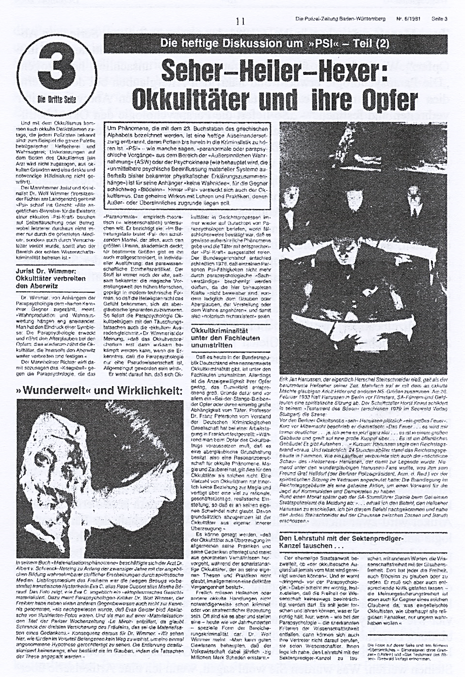

A special event caused quite a stir in all of Germany and adjacent nations in 1974. A young Israelite by the name of Uri Geller (born 20th of December 1946 in Tel Aviv) was introduced by Wim Thoelke in his ZDF show “Drei mal Neun” on the 17th of January 1974. He was given a number of forks and spoons in front of a running camera and he demonstrated how he could break some of them by holding his hand over them and how he could bend others by rubbing them lightly between his thumb and index finger. Besides this, he also made defective timepieces work again by holding his hands over them. He furthermore encouraged television viewers to bring out cutlery and their defective watches and clocks and place them on a table on front of them, this with the idea that they might bend and that the timepieces might work again.

The strange and wonderful eventuated: Many viewers reported after that their forks bent and their clocks worked again.

Television stations and newspapers received thousands of calls about successful experiments.

Something particularly drastic happened with the Family Scheid from Karlstadt am Main. Mrs. Barbara Scheid (63) sat in front of her television set with her daughter Elfriede and two of her grandchildren. During the broadcast the daughter said in jest: “I hope that our silver cutlery isn’t also broken.” The mother and one of the grandchildren went to an adjoining room and opened a couple of drawers of a sideboard. The shock was great: 42 pieces of cutlery had already deformed in the two drawers, spoons, teaspoons, cake forks, a cake scoop and a ladle. Two pieces were broken. Mrs. Scheid was so terrified that she called the police and asked for help.

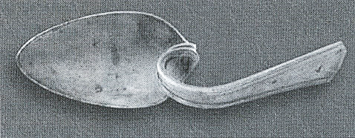
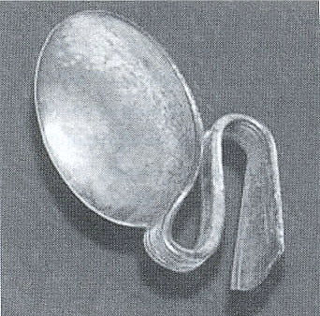

Some of the 53 bent pieces of cutlery of the

Family Scheid.

Police inspector Horst Kessler and police chief Horst Hammer did indeed arrive at their flat soon after. Nine more pieces of cutlery bend in front of their eyes. Within 90 minutes, 53 pieces of silver cutlery had deformed.

A television viewer from the GDR entered his bedroom after a similar program had aired on the 19th of January 1974 and he heard short bursts of whistling and hissing coming from his wall safe. When he opened the safe, he noticed that an album with silver coins stored within had doubled in size. He opened the album to find that all coins had suffered a slight kink and this had doubled the size of the album. He figured that the damaged this had caused him was around 50,000.00 DM. A watchmaker in Hamburg on the other hand was lucky. From 13 alarm clock in for repair, five worked perfectly and they no longer had to be repaired. Similar shows with Uri Geller were also broadcast in Switzerland, Austria and England. With the same results everywhere.

I personally experienced a performance by Uri Geller in Düsseldorf and it dealt with telepathy and spiritual healing. He was very impressive there also. The subsequently ensuing research established that a number of children, juveniles and adults could also produce such phenomena, for example the bending of metal objects sealed in a glass tube in the presence of an appropriately gifted child.

Newspaper commentators, psychoanalysts, lawyers (Wimmer and Schäfer) and stage magicians felt obliged to unbend the bend worldview produced by Uri Geller. They declared that everything was sleight of hand paired with miracle hysteria. As far as they were concerned, this closed the case.

Prompted by an SPD delegate, even the German Bundestag concerned itself with this problem.

German Bundestag – 7th Electoral Term
79th sitting.
Bonn, Thursday the 14th of February 1974,
Page 5048

Vice-President von Hassel: We now come to the questions from the area of responsibility of the Federal Minister for Research and Technology and Postal and Telecommunication. The parliamentary State Secretary Dr. Hauff is at our disposal to answer questions.
I refer to question 76 by representative Dr. Meinecke (Hamburg).
What importance does the Federal Government ascribe to Parapsychology?
The questioner is present.
May the Parliamentary State Secretary answer, please!

Dr. Hauff, Parliamentary State Secretary for the Federal Minister for Research and Technology and Postal and Telecommunication.
Mister President, I ask permission from the questioner to answer both questions simultaneously.

Vice-President von Hassel: No concerns.
Question 77 by representative Dr. Meinecke (Hamburg) is also tabled here, namely ‘ Does the Federal Government feel obliged to support parapsychological research to a considerable degree after the events of recent times?’

Dr. Hauff, Parliamentary State Secretary for the Federal Minister for Research and Technology and Postal and Telecommunication.
Colleague Meinecke, as you know yourself, there are a number of researchers and institutes at universities, for instance the Institute for Borderline Psychology, Freiburg, that deals with parapsychology in a serious manner. Decisions for its promotion are taken by the self-governing body of the sciences. So-called border issues of the sciences like parapsychology, undoubtedly belong within basic research. In this respect, something Federal Minister Ehmke emphasised in his speech at the Max-Planck-Institute on the 29th of June 1973, federal departments are well advised to not try to influence detailed decisions. Their capacity – one might say more appropriately – their clairvoyant capacities do not suffice.

Vice-President von Hassel: An additional question by the representative Dr. Meinecke.

Dr. Meinecke (Hamburg) SPD):
State Secretary, does the federal parliament share my opinion and my concerns, that parapsychological epidemics, like for instance the one that was triggered by ‘certain people’ in the mass media, must be scientifically investigated and socio-politically researched, particularly in light of the mass influence through phenomena or also through trickery?

Dr. Hauff, Parliamentary State Secretary for the Federal Minister for Research and Technology and Postal and Telecommunication.
Mr. Representative, I would like to use your additional question to explain that the events you touched upon must be very accurately investigated, particularly in regards to the fact that with the polarisation of such parapsychological insights and practices, one has to take into consideration that the German cutlery industry could experience a considerable collapse of its output. Such a decision would also have an employment-political and structural-political effect that will have to be considered.

(Applause from the governing parties)
Besides, Mr. Representative, the question of liability in regards to the afflicted is still completely unresolved. It could also be questioned whether this region of research could actually improve the quality of life. For as long as the related questions have not been finally and conclusively cleared up, the Federal Ministry for Research and Technology assumes that the need of society for a considerable boost for this type of parapsychological research cannot be presumed.

Vice-President von Hassel: A second additional question from the Representative Dr. Meinecke.

Dr. Meinecke (Hamburg) SPD):
Mr. State Secretary, even though I might share your opinion and that of the Federal Parliament, I would still like to ask you: Why is it that the main focus of parapsychological research has been intensively promoted in the United States and the Soviet Union over the last years and do you not believe that the Federal Government might be in danger of losing international contact, particularly in light of the revealed paranormal phenomena and in regards to certain problems of manned space travel?

Dr. Hauff, Parliamentary State Secretary for the Federal Minister for Research and Technology and Postal and Telecommunication.
Colleague Meinecke, as far as the Federal Government is concerned, we are dealing – at least in America – mostly with private initiatives and private foundations. Particularly in regards to today’s negotiations within the German Bundestag, it is not inappropriate to indicate that the German Parliament expressively welcomes any private promotion of research activities.

Vice-President von Hassel: A third additional question from Representative Dr. Meinecke.

Dr. Meinecke (Hamburg) SPD)
Can I possibly establish an accordance with the Federal Government’s opinion – in light of today’s proceedings - that the utilisation of psychokinetic impulses and energies are not suitable in regards to solving the energy crisis?

Dr. Hauff, Parliamentary State Secretary for the Federal Minister for Research and Technology and Postal and Telecommunication.
You assessment of the situation is in complete agreement with the opinion of the Federal Ministry for Research and Technology.”

This debate shows that the representatives saw more of a humorous side to this affair. Actually, nothing happened over the next 30 years in regards to supporting parapsychological research in Germany. If a politician or an eminent researcher should seriously dare to ask for publicly promoted research in the field of parapsychology, he would be publicly slain by journalists. The choice of words used were seen as appropriate and not offensive in 1981 by our former Federal President and at that time Minister for the Interior of Baden-Württemberg Roman Herzog, who was also a lawyer. This is why no eminent researcher will expose himself to the danger of committing social and scientific suicide.

Vice-President von Hassel: One last additional question from representative Dr. Meinecke.

Dr. Meinecke (Hamburg) SPD)
Mr. State Secretary, does the federal government at least hold the opinion that not only clarification and verification in regards to these phenomena belong within this research, but also the psycho-hygienic aspect, that is to say, the clarification about damaging effects of such phenomena, like the belief in miracles, miracle healings, contacts with the hereafter or the curious receptivity of our population in regards to such phenomena?

Dr. Hauff, Parliamentary State Secretary for the Federal Minister for Research and Technology and Postal and Telecommunication.
Colleague Meinecke, I am not able to give you an answer to your question, whereby I cannot exclude that fact that it is also beyond my capability to tell you whether mysterious forces stop me from answering.

(Hilarity and applause from the ruling parties.)

One more question should be asked at the end of this chapter, namely how things stand in Germany in regards to freedom of opinion and freedom of religion.

Parapsychology doesn’t just find evidence of one’s personal survival after one’s physical death based on experience, but it also deals with the question of whether human beings must not live numerous times here on Earth. It is about whether reincarnation, ergo terrestrial rebirth exists. Researchers, like for instance the American psychiatrist Professor Jan Stevenson, investigated and documented cases where little children, after they started to talk, asserted that they have lived on Earth before and this not all that long ago. They were able to accurately depict their former place of residence, their parents and other relatives and the way they died. Professor Stevenson investigated these statements and could ascertain that they corresponded with the facts. When the children were taken along, they actually recognised their former parents. This is seen as evidence for terrestrial rebirth.

In a number of religions, like Hinduism and Buddhism, the doctrine of reincarnation occupies a central position. The doctrine of reincarnation was also promoted within Christendom by the Church father Origen (185 – 254). It was only interdicted in 543 by the Roman Emperor Justinian in an edict. I depicted details of this in my writing “Das Fortleben nach dem Tode and irdische Wiedergeburt”.

The doctrine of reincarnation is once again promoted by all Christin-spiritual minded people, so for instance by the followers of Greber and Kardec. There are millions of the latter in South-America.

The doctrine of reincarnation stand in contrast to the doctrine of eternal damnation promoted by the major Churches. The latter doctrine does not give a satisfactory answer to the suffering on this Earth.

The eminent Belgian poet and philosopher Maurice Maeterlinck (1862 – 1949, Nobel Prize for Literature 1911) portraits the importance of the doctrine of reincarnation as follows:

“There has never been a belief that is more beautiful, just, purer, moral, fruitful, comforting and more probable than the belief in reincarnation. In its doctrine of gradual atonement and refinement of all physical and spiritual inequalities, all social injustices, all outrageous iniquities of fate, it alone gives everything meaning.”

The inferences of the doctrine of reincarnation consist therein, that the progress of the present terrestrial life, ergo suffering, success etc. are conditional to negative or bad deeds of the previous life. This is given the term of Karma.

There is an author, Tom Hockemeyer, who writes his novels under the artist name of Trutz Hardo. I have known him personally for 15 years. He is an extremely nice, helpful and peace-loving person. He is a convinced advocate of the doctrine of reincarnation and he organises so-called regression seminars. In these, participants are placed into a state through verbal suggestion, that makes them have inner experiences that seem to come from past lives.

Next to his other works, Hockemeyer published a novel in 1996 titled “Jedem das Seine” (Each to his own). This was at that time the motto (Suum Quique) of the Prussian Schwarzen Adler-Ordens (Black Eagle Order), the highest honour Prussia had to offer. The question of reincarnation, in conjunction of the main character of this novel, is thoroughly dealt with, with the result that a committed guilt in a past life can lead to a terrible fate in the present life.

And this had for instance also happened to the Jews in Germany’s Third Reich, when they were murdered in huge numbers in concentration camps. The conclusion follows quite naturally from the law of karma, the way this religious belief is held as true by at least a billion of people on this Earth.

It is now astonishing that there is a religious direction in Judaism that bases itself on reincarnation, thereby affirming the law of karma. The highly respected Chief Rabbi Ovadia Yussef expressed himself along these lines on the 5th of August 2000 (printed in the journal Ha’ arez on the 7th of August 2000):

“The six million Jews, all those poor people that found themselves in the hands of evil, the Nazis – was this completely senseless? No. They were the reincarnations of past souls that sinned and encouraged others to sin and committed a whole series of forbidden things, these poor people that had to suffer all kinds of tortures, hardships and death, when they were killed during the holocaust. All of them were reincarnated souls. This life is not the first time their souls made an appearance. They came to atone for their sins. We must believe in these things. Those that do not believe this are non-believers.”

The journal Ha’ arez also adds: With this speech, the most influential Rabbi of present day Israel had turned the Kabbalist’s theme of reincarnation into a component of the Jewish religious doctrine.

This announcement was also printed in an abridged form in the German press and nobody here (in contrast to Israel) had become publicly excited about it.

But Mr. Hockemeyer had a completely different experience. On the 26th of March 1997, whilst Mr. Hockemeyer was abroad on holidays, three policemen entered his flat in Berlin, search through it and confiscated a series of documents. The District Court in Koblenz simultaneously started a preliminary investigation against him for inciting the public and for deformation.

The Green’s politician Jutta Dithfurt, the daughter of Professor Hoimar von Dithfurt, had organised a demonstration of around 150 people on the 27th of November 1996 in front of an esoteric bookstore in Darmstadt against Hockemeyer and his book. Franz Alt, C. G. Jung and the Dalai Lama were also denounced on this occasion. One week later, Hockemeyer was even shot at through a closed, ground-level window during a group repatriation.

A hearing took place at the district court in Neuwied on the 2nd of April 1998 for inciting the public and denigration of the memory of the deceased. The district attorney filed for one year imprisonment and a fine of DM 5’000. The verdict was pronounced on the 4th of May 1998 and included a fine of DM 4’000 and the banning of the book “Jedem das Seine”.

Hockemeyer appealed. Five days before the trial went to court for the second instance, his car was set alight in Berlin and it was a write-off.

The first hearing in front of the district court in Koblenz took place on the 23rd of May 2000. Mr. Hockemeyer presented amongst other things:

“When I delve into new scientific insights in my novel ‘Jedem das Seine’ one must not see it as an affront, because it is certainly not my intention to insult anybody. It is rather a case of presenting a new, expanded understanding for our existence here on Earth, ergo to presenting new directions and possible explanations for our existence on Earth, the way the latest research into reincarnation indicates.”

The court did not allow itself to be influenced in any way by such argumentations. The verdict on the 30th of May 2000, was once again DM 4’500 and the banning of the book. The grounds for the verdict contained amongst other things:

“The accused cannot appeal to the freedom of doctrine and belief, conscience and confession. Judged by the constitutional order of values, these freedoms take second place behind honour and human dignity and others that have to be respected.”

Now we know: The law of karma – if it really exists – can apply to everyone around the whole world. Only in Germany (but not even in Israel) has it been abrogated in regards to Jews through a court order. One can express any blasphemy in Germany or proclaim that soldiers are murderers. All of this is legitimised through freedom of speech. But when something is expressed in Germany that Jews might find unpleasant, one quickly stands in front of a judge accused of inciting the public. One might consider the fact that in its strictest application, it also applies to millions of Reich-Germans and other Germans that lost their life after the last war through displacement, forced labour and in captivity.

With the doctrine of reincarnation and the law of karma, we are dealing with a religious philosophy. Legal processes concerning the astronomical view of the world that should be gotten rid of, already took place four hundred years ago. It concerned the discoveries of the Frauenburger Canon and astronomer Nicolaus Copernicus (1473 – 1543). He replaced the antiquated, geocentric view of the world with the heliocentric view of the world, that is to say, he recognised that the Sun was the centre of the planetary system and not the Earth. This stood in contrast to what the Catholic Church saw as the truth.

The very famous Italian mathematician and astronomer Galileo Galilei (1564 – 1642) came out in favour of this doctrine in 1613 in his dissertation about sunspots. This brought him in front of the court of inquisition in Rome during 1615/16. The entire Copernican doctrine was banned and Galileo forbidden the teach it or defend it.

Galileo did however not abide by this and instead published a novel in 1632, that is to say, a fictitious account that he called Dialoghi (dialogue). In this, two people, a simpleton and a pundit discuss the Copernican view of the world. The simpleton defends the geocentric view of the Church and the pundit the heliocentric view of Copernicus.

In 1632, Galileo was very quickly dragged in front of the court of inquisition and condemned to an undetermined length of time in prison. Besides, in a solemn session of the Holy Office, he had to renounce the Copernican doctrine on the 22nd of June 1633 whilst on his knees with the words:

I, Galileo Galilei, son of the late Vincenzo Galilei of Florence, aged seventy years, being brought personally to judgment, and kneeling before you, Most Eminent and Most Reverend Lords Cardinals, General Inquisitors of the Universal Christian Commonwealth against heretical depravity, having before my eyes the Holy Gospels which I touch with my own hands, swear that I have always believed, and, with the help of God, will in future believe, every article which the Holy Catholic and Apostolic Church of Rome holds, teaches, and preaches. But because I have been enjoined, by this Holy Office, altogether to abandon the false opinion which maintains that the Sun is the centre and immovable, and forbidden to hold, defend, or teach, the said false doctrine in any manner ... I am willing to remove from the minds of your Eminences, and of every Catholic Christian, this vehement suspicion rightly entertained towards me, therefore, with a sincere heart and unfeigned faith, I abjure, curse, and detest the said errors and heresies, and generally every other error and sect contrary to the said Holy Church; and I swear that I will never more in future say, or assert anything, verbally or in writing, which may give rise to a similar suspicion of me; but that if I shall know any heretic, or anyone suspected of heresy, I will denounce him to this Holy Office, or to the Inquisitor and Ordinary of the place in which I may be. I swear, moreover, and promise that I will fulfil and observe fully all the penances which have been or shall be laid on me by this Holy Office…”

One does not have to take an oath in comparable cases whilst on one’s knees these days, but one can still end up in jail or at least pocket a hefty fine. And a ban, like the one Galileo received, can still be put in place.

* * * * * * *

See the Menetekel protocol “Reincarnation” with extracts from Church books.

