PSYCHO-SCIENTIFIC FRONTIERS

Selected publications from a variety of subjects of psycho-scientific research. Editor: Rolf Linnemann (Certificated Engineer) * Steinweg 3b * 32108 Bad Salzuflen * Tel. (05222) 6558

Internet: http://www.psychowissenschaften.de E-Mail: RoLi@psygrenz.de
Translator’s email: evak30@optusnet.com.au

Thoughts and research results based on physics

Title : Scientific insights verify

God’s existence

Author : Bachelor of Science in Physics, Lilo Haslinger

Preface

Our knowledge is piecework. The sciences based on experience that we practise are far from being completed and we know in advance that new disciplines will be added in the future. We can therefore presently not come to the conclusion that our philosophy, our view of the world, is somehow finalised. This is particularly not the case because the most important natural phenomena required to base our view of the world on, remain chiefly dark and enigmatic.

Astronomy encompasses the largest sector and it has experienced the greatest development, but insights into merely external natural phenomena have little impact from a philosophical point of view and the sight of the stars give us only impressions that remain stuck in our sphere of feelings to a lesser or higher degree, because the world still remains a large question mark.

If we restrict our view to our Earth,our plight is just the same. Things within mineralogy for instance are relatively clear, but we cannot draw philosophical conclusions from them. Biology on the other hand, it is incomparably more important, teems with enigmas. Human beings, the highest form of all natural facts, are altogether the greatest enigma. They are not even quite comprehensible from their physiological side; their psychology, it deals with the highest functions, is very much a battleground of opinions that present quite opposing definitions of what human beings are all about. Some see us as a heap of chemicals, whilst others see us as an emanation of God.

The fate of all of philosophy does therefore virtually depend on psychology; as human beings can only be sufficiently explained through their highest apparitions, we find that this also applies to nature’s highest apparitions which in turn suggest that human beings connote the bloom of Mother Nature we are familiar with. Therefore, a philosopher interested in metaphysics without giving justice to psychology, would be akin to a botanist who would ignore the fruit of a fruit tree when describing a tree.

The facts of nature are indeed not equal when it comes to explaining the world and the more important they are, the darker they unfortunately are. We must therefore adjourn our attempts to solve the enigma the world represents to us until we have solved the enigma human beings represent first and in particular the psychological side, that is to say, the enigma of the human soul.

Bad Salzuflen, August 2002

A lot of people live as if they were immortal. And when they are too old and too weak to live the kind of life they hoped for in years from now, they fret in silence and with empty eyes about the dreams they could have lived if they had not trusted in “later”. I am appalled when I see so many young people whose skin is a smooth as silk, but whose eyes are nearly as empty as they could be.

Kristiane Allert-Wybranietz

1. Introduction

How can I explain to all my fellow human beings how inwardly beautiful life can be if one recognises its deeper meaning?

I observe over again that most people only orientate themselves on externalities, that they only believe what they “see” with what they call their physical eyes, ergo that they factor out an area of life that is actually the most precious.

It comes as no surprise that a lot of people become empty and that this emptiness must be filled with distractions and all kinds of stimulantions. But those that listen inside themselves during a quiet moment, become calm and ask: “Am I happy?”, “Do I live a fulfilled life?”, “Do I live what I yearn for deep inside of me?”, might, depending on the level of consciousness of their ego, feel the answer, namely how little living only for externalities brings. How insignificant it is to only live to eat and to drink, to live for the house and the car, to worry about how one looks, a successful carrier, well brought up children, a clean home, the hustle of the city, everyday life, a sunburned holiday, gossiping with neighbours, being politically pulled in this and that direction or the tense “cohabitation” with others.

Is this all there is…? Is this what life is all about…?

Does not each of us carry a yearning for more inside?

Why is it so, why do most people only see externalities, only believe what they see, only think about physical things and live in a materialistic way? See the question of the meaning of life only in the light of Darwin’s “battle of survival” and deny God’s existence (Even though they might secretly wish for his reality, specifically when they look at the situation the world is in). But a lot of people still hold the opinion that he couldn’t exist, because alleged scientific insights and all intellectual contemplations indicate the non-existence of God.

Is it so?

The thoughts of many people are actually thoughts that were not formed in one human life, but already during the last 300 years.

As philosophers like Descartes, Comte, Hegel and Feuerbach wrote down their thoughts, the rest of the world did not grasp the explosiveness within these ideas for some time after, namely that they would change the world – but not actually in a positive way.

This materialistic breading ground of thoughts found it easy to spread across the fertile soil of the belief in science prevalent in the western world. One could almost say: Materialism has become our ideology.

This philosophical idea contains an unforeseen explosiveness. The thrust that diminished within the contemplations about a deeper meaning of life and about the divine status of human beings, initially with intellectuals and gradually also the broader masses, can be historically tracked. When people fear the ever increasingly appearance of difficult political currents and societal developments these days, you find that only very few are aware that the mental foundation for these circumstances lie in the secularisation of past centuries.

After the materialistic doctrines no longer provide God with a right to exist and as souls are no longer supposed to exist after death, there remains only one option according to the philosopher Martin Heidegger, namely nihilism as the meaning of life, ergo heroic desperation. As the world falls ever more out of joint and talk about humanitarianism no longer seems to be an acceptable basis in light of all sorts of ever increasing brutality, a fear of existence spreads more and more all over the place. To have to look down into the abyss of nothingness makes people shudder.

I hope that people do not find me arrogant when I say that the reasons for the production of this text is my wish to once again fill the emptiness in my fellow human beings with life, to simply take away their fear of nothingness and chaos in a scientific fashion, by showing all those that are subservient to the sciences that nature itself points out the fact that God exists.

Look upon this text as being the plain avowal of a physicist: God and a spiritual sphere of life exist and the life of every individual human being has a deeper meaning.

When I talk about God here, I neither mean the judgemental God, as he is often depicted by the Church, nor the dogmatic God of some sects.

God is rather revealed to me through nature as the ORIGINAL FORCE behind everything that exists, as a force that permeates through all forms of existence, as the energy all of us exist from – as the creator and maintainer of all worlds.

This is the God I am talking about; he is our father.

2. The relativity of all perceptions

Because a lot of people only believe what they see, I would like to show to begin with what “seeing” in a physical sense means.

It is known that a body – for instance a fly agaric – can only be seen, when light falls upon it, so that it can be reflected in our eyes. If the fly agaric cannot reflect light because no light falls upon it and because it cannot produce light from within itself, we do not se the fly agaric.

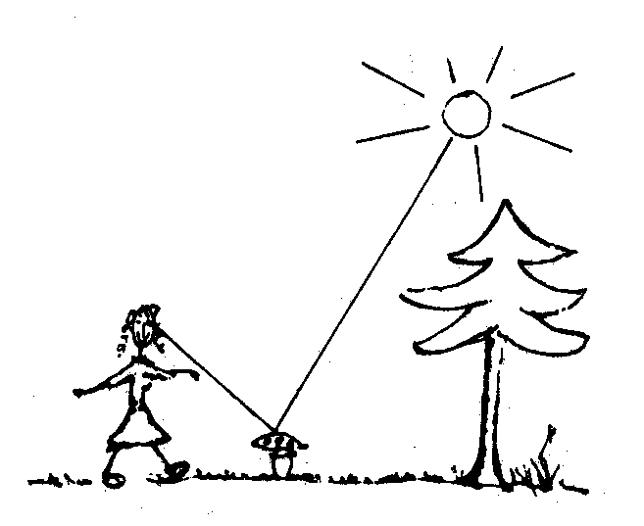

In simple terms: If we place the fly agaric into an absolutely darkened room, we will not see it, even though it is there. I would therefore like the simple question:

- Could it not be that we do not see God, because we sit in darkness?

Let us not ridicule this thought, because we must bear in mind: The physical field of optics shows us that a body that does not reflect light is invisible to us. God, for instance, could be permanently present, but if He doesn’t reflect light, the way we perceive it, He remains invisible to us.

As the following explanations show, as human beings we are actually more akin to a cave newt than an eagle in regards to our ability to see: All of us have seen a rainbow and we therefore know that white light – sunlight – consists of spectral colours, of the individual colours of the rainbow. Light, an oscillating electro-magnetic forcefield to us, can appear on various wavelengths.

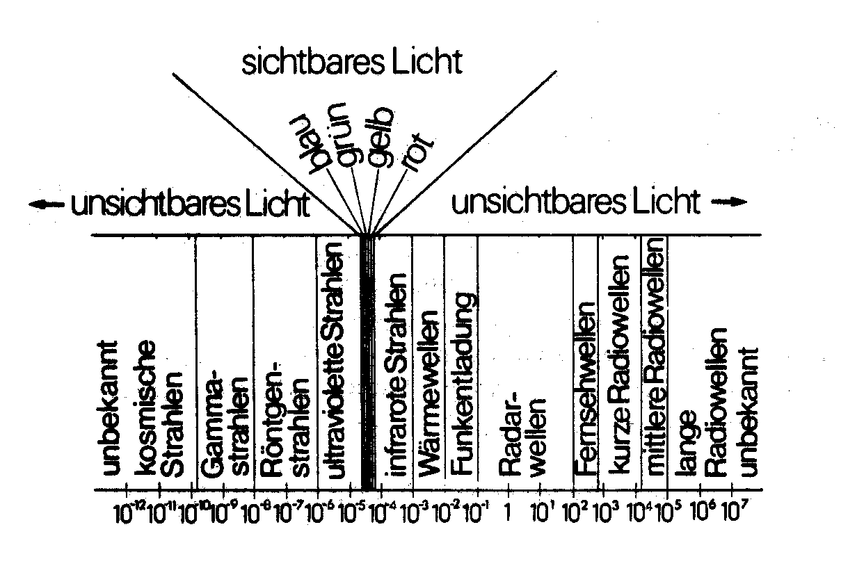
Image 2: The presently known spectrum of electro-magnetic waves. The range of visible light is only an extremely minute range within the overall spectrum.

Wavelengths in centimetres. The light visible to us lies between 1/10,000cm and 1/100,000cm. 10⁴cm means 1/10,000cm and 10³cm means 1/1,000cm
A long wave with slow oscillation has red light. Shorter wavelengths have yellow and then green light and finally blue light – specifically violet light – have the shortest wavelengths, ergo oscillate the fastest of all the colours of the spectrum.

As you can see, I have specified more than the colours of the spectrum in my presentation. This is due to the fact that more oscillating electro-magnetic forcefields exist and this with ever so short and ever so long wavelengths. One can imagine my drawing, if one chooses, to extend either to the left and the right as far as one likes to, if one would like to include all the existing electro-magnetic oscillations.

From the infinite palette of existing electro-magnetic radiation, only the middle of the range marked “visible” can be perceived by our eyes.

Compared to a being that would be able to perceive the infinitely numerous electro-magnetic radiations, we as human beings are almost blind. If one therefore relies on one’s eyes only and says: “I only believe the things that I can see”, one feels rather deserted within the palette of electro-magnetic radiation. As mentioned before: A fly agaric is only seen because it just reflects this minute part of the visible radiation into one’s eyes. Whereby the difference of a few ten thousandths of a millimetre within the wavelength makes the difference between visibility and invisibility. The wavelength of red light is 0.0007 mm whilst the wavelength of violet light is 0.0004 mm. Wavelength of 0,0008 mm or 0.0003 mm no longer produce a stimulation of the retina!

The insight that our whole knowledge of the universe is actually only based on fragmentary impressions of our imperfect senses had a sobering effect on many scientists. A lot of research into the field of physics clearly indicate our limitations. Even when we augment our human eyes through artificial “eyes” like an infrared camera or radio antennas, we, with our perceptions, remain limited to electro-magnetic waves. Even using our most sensitive instruments, we are (still) blind to any other type of radiation.

Physics certainly assumes with certainty that other types of radiations also exist. Research into the interactions of so-called elementary particles, as well as planets and suns, makes us expect that four fields of radiation exist, namely:

- From strong interactions.
- From the already mentioned electro-magnetic interactions.
- From weak interactions.
- And from gravitational interactions.

The strong interactions keep the atomic nucleus together, the electro-magnetic interactions keep atoms and molecules together and the gravitational interactions do the same for planets, suns and galaxies. The weak interactions only manifest in certain types of particle collisions and the decay of particles, like for instance with Beta-decay.

What is essential with these research results is that they show us that there must also be other fields of radiation apart from electro-magnetic radiation. As we presently do not have any opportunities to perceive these with any type of receiver or with “artificial eyes”, physicists presently search for gravitational waves, as the article rendered on page 6, published in the Kieler Nachrichten, shows.

To sum this up:

- We only see the small spectrum of light, we measure broad reaches of electro-magnetic radiation (extremely high and low frequencies are still unknown) and we assume that three further fields of radiation exist, but we have not yet been able to record them technologically.

How many types of yet unknown radiations might exist?

How small and how fragmented are our perception capabilities in spite of our technological aids! I would like to once again ask the question here:

- Is it possible that we do not see God, because we sit in darkness?

Let us take other types of beings into consideration – spirit beings – that can only live and act in another field of radiation, ergo on an electro-magnetic level; we simply cannot perceive them even if they stood directly next to us. We lack the antenna to receive, we lack the eyes to see. A being only has to have a body that reacts to a different field of radiation and it will remain absolutely invisible to us.

Well, I would like to further expand my thoughts: Our whole environment and even ourselves could be interspersed by a field of radiation unknown to us wherein whole life events could take place – and we cannot perceive any of it!

US-Astronomers are closing in on Einstein’s gravity waves.

Already predicted in the theory of relativity in 1916.

Washington (dpa) According to their statements, American scientists discovered the first concrete signs for the existence of gravitation waves Einstein assumed existed.

They could indeed not measure these waves directly, but they registered their effect on a pulsar star 150 lightyears away. Einstein predicted the existence of gravity waves, they exhibit a similar character to electro-magnetic waves, in his theory of relativity in 1916.Scientists had up to then tried in vain to receive the oscillations of these waves with highly sensitive aluminium antennas amongst other things.
A group of radio-astronomers from the University of Massachusetts, under the direction of Dr. Joseph Taylor, chose a new method. As from 1974, they began to record the signals from a pulsar that was about 150 lightyears away. A pulsar is a celestial object that emits consistent radio signals with clockwork regularity. The pulsar selected by the scientists orbits around another, massive celestial object, possibly another pulsar or one of the mysterious “black holes”.
Einstein had predicted that such a system would emit gravity waves and that it would display a small but constant loss of energy. Due to this loss of energy, both of these celestial bodies, thus circling around each other, would have to gradually approach one another over time and the rotation of the system would slowly diminish. According to Einstein’s theoretical calculations, the orbital time would be reduced by a ten thousandth part of a second per year.
Through observation with the 330m parabola dish in Arecibo )Puerto Rico), American scientist discovered that the orbit of the pulsar had reduced by four ten thousandth part of a second since observations began in 1974 – practically coinciding exactly with Einstein’s prediction.
“We assert that we discovered an indirect effect of gravity emissions and that this suffices to verify the existence of the effect” explained team leader Taylor. Taylor wants to present the findings of the research project at an international congress in Munich in the near future.

This idea is specifically confirmed through the fact that matter – something I will show more elaborately later – only proved to be a dense section within a field. From a physical point of view, our statements about the existence or non-existence of other worlds must be considerably more careful and precise. We might already find that the assertion that something didn’t exist because we cannot see it might be outright ridiculous from the point of view of a physicist. All physicists can say is: What I do nor see does not live and react within the electro-magnetic field of radiation.

Someone who believes that something doesn’t exist, because he or technology cannot see it, reminds me of a child that believes that when it keeps its eyes closed, nobody else could see it also.

Those that seriously believe that they can only believe the things they actually see (including seeing with technological means) must realise the kind of fragments they depend upon. They must be clear about the fact that they set very limited boundaries in regards to what they see: They restrict their vision to within the electro-magnetic field of radiation.

The following thought experiment is also designed to show how small and how restricted our perception is even with the help of technology. It is generally known that we live in a three dimensional world. The first dimension indicates the length, the second the width and the third dimension the height of an object, like for instance a house:

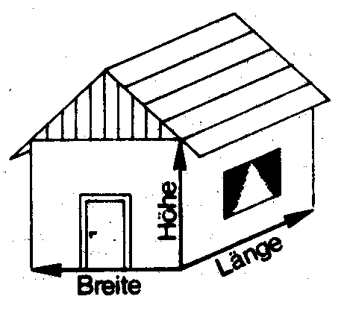

Breite = Width, Länge = Length, Höhe = Height

Let us try to imagine a one-dimensional being, one that lives within length for instance: It only knows one direction, namely length and it is aware of front and back. Its capacity to think does not include right or left, up or down, that is to say, width and height.

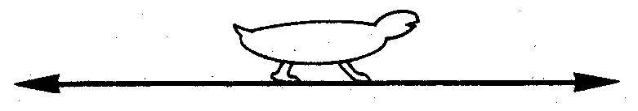

If such a being wants to be alone and not be seen by anybody else, it will build a protecting “wall” at the front and the back. It now feels – as it can only think one-dimensional – absolutely secure, it can no longer see anyone and recons that nobody can see it. This also applies for all other one-dimensional beings.

But a two-dimensional being will already ridicule this behaviour and, in its two dimensional existence, will be able to stand next to the one-dimensional being without being seen by it, and it will be able to observe everything the one-dimensional does within its two protective walls.

This two-dimensional person also lives on a plane and apart from the dimension of length, it also grasps the dimension of width. This being will therefore build a house with four “walls” for itself, left and right, back and front and it will believe that it is now protected on all sides.

But we from the third dimension also smile at this behaviour and we simply look into the house of this two-dimensional being from our third dimensional vantage point without being seen by it, because it cannot grasp the third dimension and it does not know height.
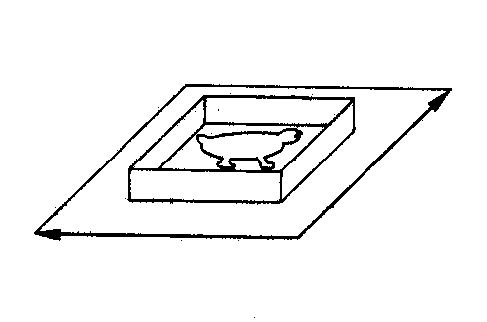

Let us now a look at our houses. We also lock our places like the one- and the two-dimensional being in the direction of our known dimensions: Length, width and height. A being from the fourth-dimension can also smilingly observe us without us being able to see this entity, even though – seen from a fourth dimensional point of view – it can stand directly next to us.

Isn’t it again remarkable how restricted the perception capability of human beings are here also, how restricted our “seeing” is? In spite of all our technical apparatuses and our advanced achievements we have unfortunately to remain within our three dimensions!

- Let us summarise: Ergo, we cannot see more than three dimensions and, even with the help of our technology, only within the electro-magnetic spectrum.

Let’s assume there was a God. Do we really expect him to don the tight belt of life within the electro-magnetic spectrum, thereby penning up his existence within a three-dimensional world?

Do we not have to ask ourselves the serious question of whether we grasp the objective reality of our existence with our eyes and measuring devices?

Do the simple observations of our three dimensions and our optical capacity to perceive things rather show the limitation – I almost said imprisonment - of our external human existence?

These physical contemplations lead us to one insight, one that the Greek philosopher Plato already gained around 400 BC, when he said: “The visible world is our prison” [1]. It will be difficult to leave this prison with only our external senses.

But things get even worse!

Even the things that we profess to recognise within our three dimensions and the electro-magnetic spectrum prove to be an illusion! Everything is the way it is because we think that it is so and not because it actually is so.

The well-known mathematician and philosopher Gottfried Wilhelm Leibnitz (around 1700) wrote:

“I am capable of proving that not only light, colour, heat and similar things are only apparent characteristics, but that form, expansion and movement are equally the same” [29].

Leibnitz had already recognised what the latest insights in physics confirm: Nothing of what we can perceive is absolute so that we can say “it is”, but everything is relative and only appears to human beings as a specific structure.

None other than the famous physicist Albert Einstein pursued these thoughts to their last consequence by revealing in his theory of relativity that even time and space are only forms of contemplations. Neither our very familiar progress of time – we are young and we grow old, the ticking of seconds – is absolute (no, the terrestrial lapse of time is relative and tied to us and it cannot be applied to extraterrestrial life) nor our perception of size and expansion of a body within the three dimensions is absolute. The size of a body is also relative and tied to our human existence. Extraterrestrial life could possibly perceive distances and routes, heights and widths in a completely different magnitude.

I would like to explain the relativity of time on hand of “black holes” that represent the most mysterious and fascinating objects modern astrophysics delves into. One thinks, from a theoretical point of view, that one is dealing with a star that has collapsed into an unimaginably dense mass with a force of attraction that has become so enormous that even its own light can no longer escape it. It can therefore not emit any light and therefore appears black.

The enormous attraction of mass or gravity – physicists talk about a severe bending of the space-time continuum – would also prevent the light from such a star from reaching us - and that it would simultaneously have a marked effect on time.

Let’s assume that we could install a clock on a star that is about to collapse into a black hole, whereby “clock” means an instrument that regularly sends out signals like the tick-tock of a metronome. We would then paradoxically notice that the tick-tock of the signals slows down – the time on the star therefore no longer advances as fast as before – the closer the star nears it collapse! No signals would eventually reach us once the star has turned into a “black hole”.

An outside observer would therefore have to come to the conclusion that the stars slows down as it collapses and that it comes to a complete stop once the moment of the event horizon has been reached. The star itself does however not experience anything special as it collapses beyond the event horizon. Time continues to flow normally for it and the collapse comes to an end after a finite period of time once the star has constricted to the point of infinite density.

But how long does the collapse actually go on?

A finite or an infinite time?

Such a question does not make sense within the world of the theory of relativity. The lifespan of a collapsing star is as relative as all other timespans and it depends on the frame of reference of the observer.

I would like to explain the relativity of time through another example, namely the lifespan of a human being: the twin paradox, the way Roman Sexl describes it in his school books for gymnasiums.

In order to understand this better I have to mention at the outset that time flows slower for an object that moves at a higher speed than an object at rest. If for instance a spaceship would fly past our Earth at great speed and we had the opportunity to make a time comparison via radio signals, we would find that our time moves faster than that on the spaceship.

This changed lapse of time of a moving system in contrast of a system at rest is called time dilation or shift of time. The theory of relativity also offers equations that can be used to calculate the time dilation, but I do not want to deal with them here. The essence of both of their statements are:

- The greater the speed of a body is relative to us; the slower time passes for it when compared to our time.

- The time dilation only reveals itself to us in experiments, when the body moves at a speed that approaches the speed of light.

Here now Roman Sexl with his twin paradox:

“Imagine one brother of a set of twins undertaking a space journey that leads him across the universe at great speed for a number of years, whilst the other brother remains back on Earth. The time dilation makes the clocks on board the spaceship go slower. But not only clocks on board are affected. Plants in the spaceship will grow less fast and the heart of the space traveller will not beat as often as the heart of the other brother. As all temporal process are equally slowed down, the travelling twin brother will not perceive any of this. Only once he returns to Earth will he meet his twin brother who is a number of years older. Imagine the grotesque situation when the returning twin does not recognise the old man on Earth as his twin, whilst the man emerging from the spaceship sees himself the way he looked many years ago.” [3]

This here is not some fantastic science-fiction novel, even though this experiment would require very high rocket speeds. Physics these days is convinced that time for a space traveller moves slower than for the people on Earth. The already realised flights to the Moon showed that the astronauts remained about one second younger than the people back on Earth.

The slowing down of clocks was specifically and thoroughly tested within elementary particle physics. In 1971, experiments in regards to time dilation were successfully carried out with atomic clocks by both American physicists Joseph Hafele and Richard Keating. The Nuclear Research Centre CERN near Geneva also gained prominence in 1975, as it excellently confirmed the life span of certain elementary particles, muons in fact, and the contemplations within the theory of relativity in regards to time dilation.

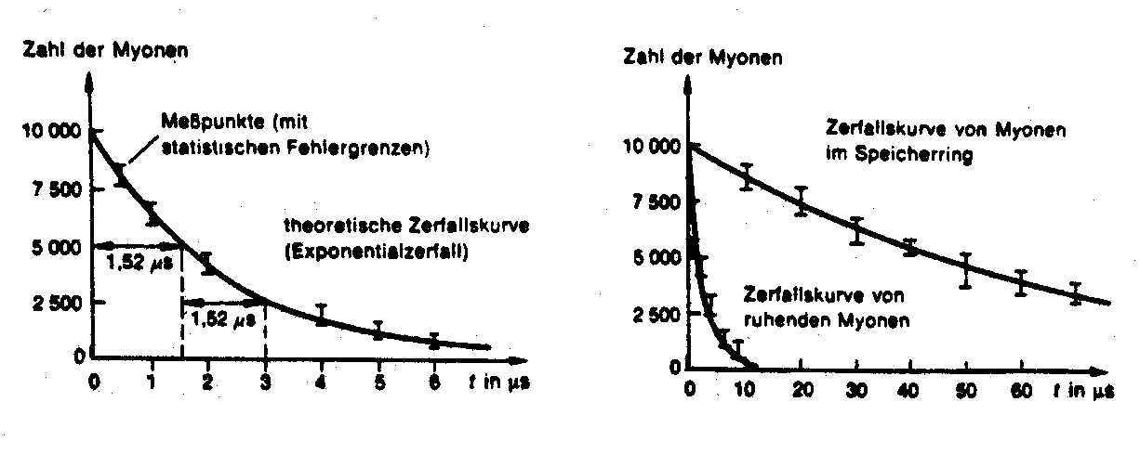
The muons circling within the storage ring therefore decay considerably slower due to the time dilation that the muons at rest. The half life span therefor lengthened by a factor of 29.4 to 44.6 μs in the CERN experiments.
The decay of muons obeys an exponential law, similar to that of radioactive decay. After T = 1.52 μs, only half of the originally present muons remained behind, when the particles are at rest.

Fast moving muons have a longer life span than muons at rest. Expressed on simple terms: One allows the muons to dash about and one can observe that they grow older.

But not only time is relative. Size and form also depend on their movement in relation to the observer and it changes with the speed of the movement.

The “Streu” experiments in high-energy physics, where particles collide at extremely high speeds, revealed that the relative abridgment is so powerful, that the spherical particles are reduced to the shape of a “pancake”. The particles are therefore reduced in size due to the high velocity.

It is therefore meaningless to ask for the “actual length” of an object, as meaningless as asking for the actual length of a person’s shadow. Its length is determined by the position of the sun and every projection angle differs according to the respective projection angle.

The length of an object is accordingly different for every circumstance of movement, that is to say, in every reference system and dependent on the speed of the reference system or the observer.

These facts are unknown in our daily life, because we move too slowly here on Earth. Only studying objects moving at great velocities, as is the case in high-energy physics, show the relativity of length and time.

Studying this reveals that Einstein’s theory of relativity is no longer a mere theory, but the scientific description of natural processes appearing in front of us, whereby I deliberately say appearing natural processes.

How we as human beings perceive something depends on our velocity relative to that of these objects. Whether we are relative to an object at rest or on the move, it changes the “actual” form of the object for us. On the one hand we think that we have a sphere in front of us and on the other hand a “pancake” and it is absolutely futile to ask how the particle actually looks like. Physics actually reveals to us: The particle represents a sphere to us from one point of view and a pancake from another point of view.

Who can grasp the deep meaning of this insight?

- The time that we perceive, the lengths and sizes that we see are not absolutes!

We, as human beings, have no absolute overview. Time and space appear to us only in a very specific way. Whether a timespan feel infinite or finite depends on our point of view, from the velocity of our movement!

This is where physics shows us the relativity of all perceptions with astonishing clarity – the relativity of all the things around us that philosophers have recognised considerably earlier, as the English philosopher Berkley wrote around 1730:

“All the choirs in heaven and the facilities on Earth, actually all the bodies that constitute the mighty construction of the world, have no substance without consciousness… The moment they are not perceived by us and do not exist in my or in the consciousness of another creature, they would have no existence if they did not exist in the consciousness of an eternal spirit.” [5]

One just cannot deny the fact that the things we perceive do not constitute an objective grasping of things. Our subjective point of view is crucial in regards to the results of all physical measurements. We cannot say that an object is in fact the way we perceive it with our limited senses. Therefore, an interaction between object and perceiver exists. I perceive the object in the way my senses are tuned into it. This is why every observer has their own relationship to an object.

Bertrand Russel (British mathematician and philosopher 1872 – 1970) explained this circumstance as follows in his book “The ABC of the theory of relativity” with the example of the table:

“Someone with a healthy common sense imagines, when he sees a table, that he sees a table. This is a crass deception. Certain rays of light hit his eyes when the exponent with a healthy common sense see a table, and these are of a type that stand in relation with earlier experiences with specific tactile sensations as well as the attestations of other people that they also see a table.

But nothing of all of this has ever brought us to the table. Light waves produced processes in our eyes and also caused processes in our optic nerve and they in turn caused processes in the brain.

Every one of these processes, if they had happened without their usual precursors, would have produced the perception within us that we ‘see a table’, even if no table had existed. In regards to the sense of touch that we have, when we press our fingers on the table, we are dealing with an electrical disturbance of electrons and protons in our fingertips, that are caused, according to modern physics, through the density of electrons and protons of the table. Even if these disturbances in our fingertips had been produced through other means, we would still have the same sensations even if no table was there,” [6]

What conclusions can be derived from this?

We might have to agree with the words of Herman von Helmholtz (Physicist around 1870) who wrote:

“We can derive from this that the characteristic of natural objects do actually not describe individual objects as it were in spite of their name, but always show a relationship to the second object (including our sensory organs) … that all characteristic we can ascribe to them only show effects that they have on our senses or on other natural objects.” [7]

The reality we profess to see is therefore nothing more than the interaction between these objects and ourselves. Physics shows this to us. We don’t know much more than this. We know nothing about the object – we know nothing about its actual reality.

Our present day insights into physics make it inevitably clear:

- We are locked into a small world of three dimensions and we see everything from our subjective point if view!

The whole world around us is an image that has been painted by our sensory perceptions and accepted by our consciousness. It changes when we change.

- When our consciousness begins to look for more and when we expand our impressions, this image will also expand.

An approach towards a maybe possible perception of God would therefore have to be possible through an intensification of our impressions.

Everybody is probably clear about the fact that God does not exist in this world that our subjective perceptions created. When someone would really like to experience God, they would have to pursue a different path than the one along external sensory perception.
The sciences show us that external perceptions are subjective. It elucidates the limitation of an external world to us, because it shows that this world is nothing more than a subjective interaction to other objects. It cannot lead us to objectivity via this interaction.

Once again, because this is so fundamental:

- External perceptions cannot lead us to experience God.

Human beings are endowed with many more senses besides the five senses of hearing, smelling, tasting, seeing and feeling. But the more human beings are orientated along external lines, the more stunted this sentience usually is.

All of us have surely sat under a tree or lain in high grass and listened to the noise of the wind, the rustling movements of leaves, the soft swaying of the grass in the meadow… and found out that apart from the purely acoustic hearing of these noises, a sensation was awakened within us that is difficult to describe: A kind of peace, a placid yearning, a relaxation… This sensation is however very difficult to describe to others, but this sensation was very real to us. It initially started within us – it was of a mental nature – but then had an external effect by invigorating and even healing the body.

I think that this world of sensation must be expanded if we want to find God.

The inner antennas at our disposal for these sensations are far more sensitive than our external senses. Has it become clear by now why many a spiritual world rates far higher than our world of science?

I would like to only slightly indicate the path to deeper insights and deeper understanding of our existence on hand of this example; it is neither my intension to proclaim a doctrine nor draw any kind of boundaries, I only want to induce people to individually begin to search.

Those that look for the way will also find it; because the full truth – the complete intensively experienced world of inner perceptions – is found in every human being.

Every human being must take the first step towards a higher consciousness from within themself.

3. What is matter?

All objects, everything that we can touch consists of molecular structures. Molecules are groups of atoms, whereby an atom is in each case the smallest particle within a group of around 100 known basic elements in this Earth. The atomic structure of physical matter was described by Edwin Müller in 1937 with the help of a field electron microscope. He developed a field electron microscope in 1957 that made atoms visible to a degree of a 10’000’000 magnification. The American Nobel Price Winner Richard Feynman called the insight into the structure of matter the up to now most important discoveries when he said:

“All bodies are constructed of atoms, of small but constantly moving particles. Repulsive forces come into play when atoms get too close to one another. Attractive forces come into play when atoms distance themselves too far away from one another.” [8]

It is essential to realise that atoms are not kind of “kneadable spheres” that constitute matter by sticking together, but that we are dealing with moving particles with a certain freedom of movement that are coupled together through electric forces.

A stone therefore consist of a lot of atoms that move back and forth, that are not rigidly connected to each other, but that are held together through electrical forces.

When one looks at a few drops of milk under a microscope one finds that milk consist of lively moving fat particles and the reason for this is that oscillating groups of atoms, the molecules of the water, bump into fat particles and this is evidence of the so-called “Brownian Molecular Movement”, namely the lively movement of these minutest particles. Everything is movement in a drop of milk, everything is movement in a stone, everything is movement in every piece of matter. There is nothing at rest in our universe.

What an enormous energy of movement fills all of matter!

None of us could possibly imagine this, because this mass of energy far surpasses our gift of imagination.

Ernest Rutherford (Nobel Price 1908) discovered at the beginning of the 20th century that atoms are certainly not hard and solid particles, atoms proved to mainly consist of a wide space wherein extremely small particles – electrons – move around a core. One can gain an idea of the wideness of this space if one for instance imagines an atom to be the size of St. Peter’s dome in Rome. The atomic nucleus would be the size of a grain of salt. We can gain an idea about the core and the electrons by imagining a grain of salt in the middle of the dome of St. Peter and dust particles swirling through the vast space inside the dome. The reality is that an atom is merely the size of a one hundred millionth part of a centimetre and that electrons and the nucleus are unimaginably smaller.

But if all matter – every stone – consist of moving atoms and if these atoms mainly consist of empty space with something hardly graspable inside, (electrons and nucleus) – why does matter seem so solid to us? Why don’t we reach into a void?

Hereto an example: There are hollow spaces between the propeller blades of an aircraft propeller standing still and if we were to reach between two blades, we would actually reach into empty space. But if this propeller begins to turn rapidly, one would now perceive a disk instead of individual blades, this means that a turning propeller appears as a disk to us, even though it is not a disk. If we were to try to touch this disk, we would certainly find resistance at every point of this disk. We could no longer find an empty space by touching it. Let’s apply this example to atoms. Electron race around the nucleus at enormous speed. Speeds of around 900km/sec are the norm! This is what makes the atoms seem solid to us and this is what gives matter its trusted, solid appearance.

One could think now that, in the final analysis, all physical matter is put together from the minutest of building blocks – electrons and the nucleus. One could hold the opinion that all physical matter could be reduced to the smallest, solid particles that form matter when slotted together. We could still answer the question “what is matter” on hand of our materialistic thought processes.

But an international group of recognised and notable physicists fundamentally revolutionised our thought processes in the twenties based on their discoveries. I would like to mention a few of them: The Dane Niels Bohr, the Frenchman Louis de Broglie, the Englishman Paul Dirac, the Austrian Erwin Schrödinger and Wolfgang Pauli as well as the Germans Werner Heisenberg and Albert Einstein.
The experiences these famous men had during their research into subatomic legalities, something that even astonished themselves, and the vehement discussions their results triggered in the scientific world show their citations. Heisenberg wrote:

“The vehement reaction towards the latest development within modern physics can only be grasped if one recognises that the foundation of physics and maybe even that of the natural sciences had undergone changes and that these changes produced a feeling as if the rug that sciences stood upon had been pulled from under them.” [9]

Or we hear Einstein’s feelings, even though he was known to be a courageous, free-thinking human being:

“All my attempts to assimilate the theoretical basics of physics with this new type of knowledge have failed completely. It was as if the rug had been pulled from under my feet, with no foundation anywhere in sight that one could have rebuild upon.” [10]

Niels Bohr said:

“The huge expansion of our experiences in recent times exposed the deficiency of our simple mechanical concepts thereby shaking the foundation the usual interpretations of observations were based upon.” [11]

Werner Heisenberg once again:

“I remember the numerous discussions with Bohr that lasted way into the night and almost drove us to despair. And when I walked alone through the neighbouring park at the end of such discussions the same question repeated itself over again, namely whether nature could really be as absurd as our verbal nuclear experiments exposed it to be.” [12]

What was actually so amazing about it?

What actually drove the physicists to near despair during their discussions?

- Nothing else but that these minute particles, losing themselves within the wide space of an atom, did not turn out to be the solid bodies our classical thought processes expected!

It was revealed that these subatomic units of matter were very abstract constructions. Depending on how we look at them, they sometimes appear as particles and sometimes as waves. Light actually also shows this twofold nature – as explained above, it can appear in the form of electro-magnetic waves, but also as particles.

The characteristic of matter and of light is rather strange. It seems impossible that a particle, that is to say, an object restricted to the minutest space, can simultaneously also be a wave that can expand over vast spaces. The one and the same construction can have two very different forms of appearance!

The explanation of this duality in nature completely calls the reality of matter into question.

Matter doesn’t exist with certainty on a subatomic level at specific locations, but rather shows a “tendency to exist” and atomic processes do not take place with certainty at specific times, but rather show a “tendency to appear”.

This is due to the fact that the wave attached to particles has only been interpreted as a probability. One came to this conclusion after the English physicists and Nobel Prize Winner Max Born discovered that the square amplitude of the wave (amplitude denotes the greatest deviation from rest) is equal to the possible density of the localisation of elementary particles.

An elementary particle with a greater amplitude in its “wave of probability” therefore has a greater tendency to appear, as the probability to encounter it in a specific region is great. An elementary particle with a small amplitude is correspondingly more difficult to find.

When talks turns to the wave characteristics of elementary particles one often comes to the wrong conclusion that elementary particles move within the tracks of waves. This is however not the case!

When an elementary particle appears to us as a particle, it moves in a straight line when undisturbed. But it appears as if it was a wave in many experiments in spite of this. That is to say, the particle is in turn also a wave. It actually delivers two possible forms of appearance: It can either appear as a particle moving in a straight line or it can appear as a wave.

Physics has up to now – especially after the above mentioned insights gained by Max Born – only been able to come to the conclusion: This wave must be a wave, that indicates the probability, that appears with the particle – therefore a wave of probability.

But because the concept of “wave of probability” is an abstract concept, this interpretation deprives us of the opportunity to concretely see the particle as a wave – ergo somehow pictographic.

We can therefore not describe the condition of a particle in concrete terms. It is neither present nor not present at a definite location. It doesn’t change locality nor does it stay at rest. What can change and what can be described are the structures of probability of the so-called particle and thereby the tendency of this so-called particle to exist at a certain location.

Do we realise that we are once again at the boundary of our human world of imagination?

As all of us are arrested in our material thought process, things can either be here or not here – but both here together or both not here?

I would like to tell the following to all those that have dealt with statistics and probabilities: When one observes the probable dispersion of a great number of spheres for instance, their legalities differ from the probable structure of the subatomic space. In the drawing below of an experiment, we can indeed not predict with accuracy the path such a sphere would take, we can only predict with relative certainty where it will fall. But we can certainly accurately observe it whilst it falls, indicate its position at any stage, record any collision, measure its speed and so on. We do not have this opportunity to observe in subatomic space.

We can never accurately indicate the position of an electron during the course of an experiment, nor can we accurately determine its speed nor its exact energy or location in time. Heisenberg described this fact in his so-called “uncertainty principle”.

One may therefore not simply compare the behaviour of electron with that of static particles. Similarities only appear in the prediction of probabilities, but not – and this is what’s devastating – in the actual observance of the experiment.

The paradox here is that: The more accurate we want to observe, the more accurate we want to nail the alleged material particle, the more it hides from our observations. From a physical point of view this means: The more accurate we want to measure it speed at a specific moment for instance, the reduced is its tendency to appear, the more extended the space it exist in probably is.

Everybody may say here: “I do not understand this.” Because all of us do not understand this for as long as we still look upon the particle as something small, but physical. The great physicists of our century did also not understand this whilst they were still engaged in physical thought processes.

- Only when one dares to look upon the electron as something more than a purely physical form of existence, but as something partially physical, as something that describes the transition between the physical and the purely energetical, as the link between the energetic, the spiritual and the physical, will one not only understand the process, but it will also appear to us as something completely reasonable.

We have on the one side something energetic whose structure is unlimited and who can freely disperse through space, the way physics for instance describes it via electric and magnetic fields.

Whilst we have on the other side the physical – for instance a stone – whose structure is defined and whose location is solidly determined.

Would something part-material not have to be at home in both conditions –in the material as well as the spiritual condition – and still not be absolutely in either? Must an electron therefore not naturally show its field and its wave characteristics, that is to say, sometimes adopt the energetic condition and other times the physical, that is to say, appear as a solid particle?

Electrons and other elementary particles also (like for instance the protons and neutrons of the nucleus) do however not stand alone in their dual characteristics, the spiritual and the physical in equal measure, because light also shows the same, strange behaviourism. Light was something that particularly physicists like Huygens (1629 – 1695) and Fresnel (1788 – 1827) saw as something purely energetic, because one was absolutely sure that light is a wave of electro-magnetic fields - but could however also appear in a physical state!

I would like to mention in passing that the energy field around a magnet connotes a magnetic field. It is surely generally known that our Earth’s magnetic field, as such a magnet, reaches far out into space and that it can be detected with magnetic field meters, like the needle of a compass, on board planes or ships. It also surrounds an electrical charge with a force field in a similar fashion – an electric field.

Light now consists of both fields, the ebb and flow of these fields has the form of a wave and it is called an electro-magnetic wave. Experiments like for instance the photo effect and the Compton effect have shown that light also appears as particles and that it can behave like colliding balls in a game of billiard. This physical condition of light is called photon.

Physicists were however not happy with the result, namely to acknowledge the dual characteristic of elementary particles and light. Research into the characteristic of elementary particle now began in earnest. Huge accelerator systems were built in order to make elementary particles collide with one another at great speeds and to observe them as they collided – with the hope, amongst other things, that an electron might reveal a physical character to such a degree that it could possibly break into pieces.

Such an installation can for instance be found in Hamburg and it is called Deutsches Elektronen-Synchroton – or DESY for short. Its acceleration distance is arranged in a circle that measures about 3km in circumference.

What results has one gained by observing the collision between elementary particles in these accelerator systems?

- Elementary particles certainly do not smash into physical splinter particles! Only certain transformations take place. Transformation process that lead to deeper contemplations, because they show that no basic material state exists!

Elementary particles within these accelerator systems are observed in so-called cloud chambers where they leave traces behind. These cloud chambers reveal that elementary particles have a “life span”, that is to say, only remain for a certain period of time in a specific physical state to then once again revert back into other states.

When the two original states collide, completely different physical states are formed. The collision of a pion with a proton can for instance produce completely different states: two kaons and one neutron. Above everything else, individual elementary particles do differ from one another through their mass and their charge, but also through their magnetic moment and some complicated detail behaviour during the reaction.

Two of these cloud chamber images are depicted below:
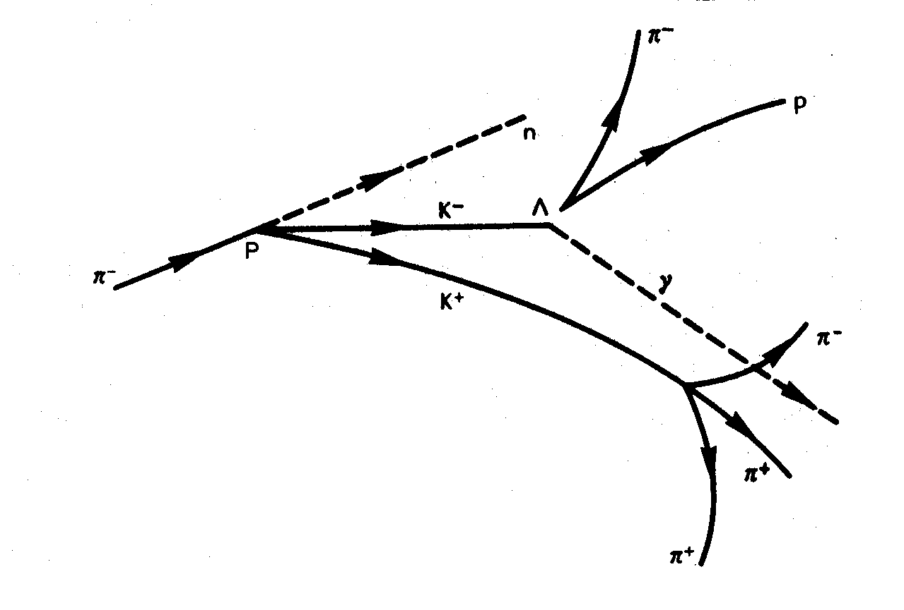
A

Image A depicts a complicated series of collisions between particles and their decay: A negative pion (π⁻) approaches from the left and collides with a proton - that is to say, with the nucleus of a hydrogen atom – that “sits” in the bubble chamber; both particles are destroyed and a neutron (n) plus two kaons (K⁻ and K⁺) are created. The neutron flies away without leaving a trace; the K⁻ collides with another proton in the chamber. Both of these particles mutually destroy one another and create a lambda (Λ) and a proton (γ). None of these neutral particles are visible, but Λ decays into a proton and an π⁻ after a short time and both of them leave traces behind. The short distance between the creation of Λ and its decay can be readily recognised in the photo. The K⁺ created during the first collision flies around for a while to then decay into three pions.

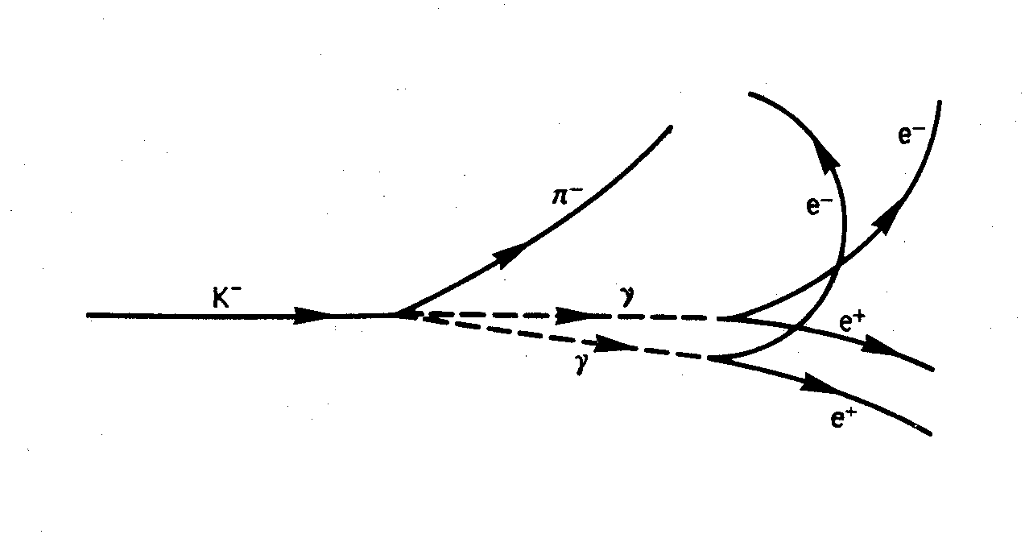
B

Image B shows a series of processes where two pairs are created: K⁻ decays into a π⁻ and two photons (γ) and each of them creates a pair of electron positrons, their positions (e⁺) curve to the right and the electrons (e⁻) to the left.

I would like to deal with the second image in more detail because of an important thought:

An elementary particle (K⁻, called Kaon) transforms into another elementary particle (π⁻, called Pion) and two photons, whereby photons actually connote the physical state of light. This transformation process actually creates light from one elementary particle.

The two photons in turn retain their state of light for a certain period of time to then transform back into two elementary particles. (I deliberately chose the word “transform” instead of the usual word of “scatter” used in the jargon, because it expresses the actual circumstances considerably better.)

Elementary particles are created from light, whereby we are however dealing with other particles than the original particles.

As the two images show, an immeasurable multitude of transformation process exist whereby the number of the present day known elementary particles far surpass the three originally known and common particles (electron, proton and neutron). The following chart may show this, it only depict stable and long-living particles:

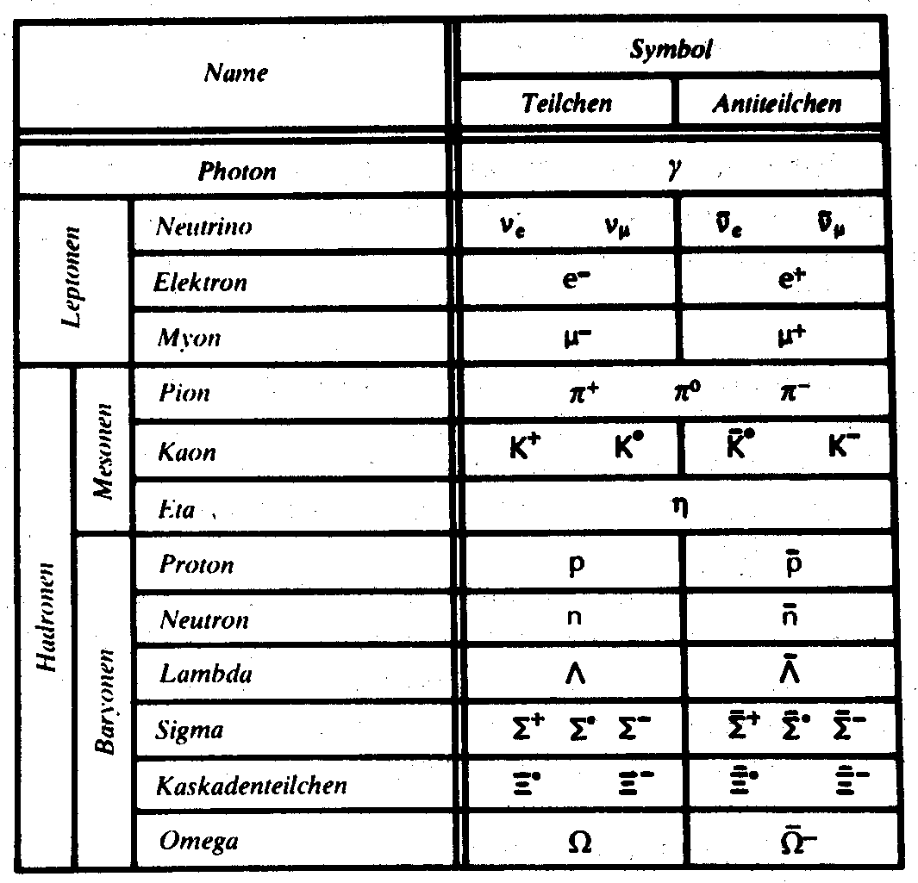
The chart shows 13 described types of particles and lots of them appear in various “states of charge”. The pions for instance can be positively charged π⁻, negatively charged π⁻ or electrically neutral π⁰. There are two types of neutrinos, one only associates with electrons (ν_{e}), the other only with muons (ν_{μ}). Anti-particles are also listed, three of the particles (γ, π⁰, η) are their own anti-particles. The particles are listed according to their ascending mass. Photons and neutrinos are without mass, electron are the lightest mass particles, muons, pions and Kaons are hundreds of times heavier than electrons, the other particles are one to three thousand times heavier.

For every elementary particle there exists a second particle and when united with the elementary particle, it radiates light. These particles are called anti-particles. Anti-particles usually have an opposite charge to elementary particles of the same mass, for instance the anti-particle to the electron, the positron.

The difference between matter and light can no longer be established with all of these transformation processes going on.

Light changes into “matter” as a matter of course and vice versa. A constant interplay between more or less physical conditions takes place: The flowing from one state to another – a demarcation between energy and matter is no longer recognisable! Matter and energy are one, well actually have to be one and the same according to the insights of elementary particle physics. Different particles are nothing more than expressions of the same – namely energy!

This is exactly what Albert Einstein discovered at the start of the 20th century and manifested in his famous equation.
E = m c²

This equation expresses how mass (m) transforms into energy (E). One must multiply it with the constant and very large factor of the square of the speed of light (c²).
Einstein’s equation can be applied to all pieces of mass. One can for instance recognise from it that 1kg of mass – maybe 1 kg of apples – contain the enormously high energy of 90,000,000,000,000,000 of joules (90 quadrillion joules). One could keep 1,000 90 Watt lightbulbs burning for around 1 million years with this energy!

Research into the transformation process of elementary particles has led physics to the decisive insight of what matter is and what is described in the so-called quantum field theory.

This most modern but not completely explored branch of physics was introduced by Albert Einstein after his futile search for a unified field and by Werner Heisenberg through his attempt to find a global formula.

The American physicists and Nobel Prize Winner Richard Feynman also gained fame within the subject of quantum field theory – his Feynman diagrams provide an excellent depiction of the transformation processes – and Murray Gell-Mann on whose deliberations about “quarks” are based also gained prominence.

The quantum field theory means nothing else but that flowing energy is the basic principle of all matter, that the free and unlimited state is the essence, ergo the spiritual that cannot be confined in regards to space, the field that penetrates and forms everything:

- Matter is just a particularly high compression of this field!

Let’s hear what Albert Einstein had to say about it:

“We can therefore regard matter as the area of space wherein the field is extremely condensed… This new physics has no room for both, field and matter, because the field is the only reality.” [13]

Or we listen to what the mathematician Hermann Weyl says about it:

“According to the field theory, a mass particle like an electron constitutes only a small area of the electrical field wherein the power of the field adopts enormously high values so that a comparably very large energy field concentrates within a relatively very small space. Such an energy node, it is certainly not clearly defined against the rest of the field, spreads through empty space like a water wave across the surface of a lake. Something like one and the same substance, the electron exists of at all times, does not exist.” [14]

A physicist must therefore say when asked: What is matter?

I formulate the answer in a way that a lot of materialists do not like to hear, but I have to say it because it is true:

- Matter is compressed spirit!

Spiritual substance, that is to say, streaming energy – compressed to a high degree – turns into matter.

4. Result

The original basis we consist of is energy.

We are the compression of this energy.

We are in a way bonded energy. Everything physical is bonded energy and therefore lives in a really constricted, deep state of energy.

But as our being is of a spiritual nature and everything physical is of spiritual origin, I ask myself why we find ourselves in such a low state of energy. Were we in higher, part-physical, freer and more spiritual circumstances at some stage in the past?

What development lies behind us?

Do we still compress more and more?

Or can we further develop into higher states of energy?

For as long as we limit our thoughts to a low, restricted physical state and are so fatuous into the bargain to negate everything else, our development towards higher regions will be nipped in the bud.
- We must open our outlook, we must widen our horizon and look upon nature from the aspect that everything is made from energy, that everything we see around us is permeated and borne by energy!

A physicist that has gained this insight turns into a believer. Not like a believer in some religious community as it were, but pious in the deeper understanding that everything is borne by an ORIGINAL FORCE, that everything has formed and is constantly being formed by an ORIGINAL ENERGY:

- The spiritual is the origin of life!

Those that have advanced to the proper insights into nuclear and quantum physics are therefore no longer surprised about the following statement by Albert Einstein, because they know that Einstein only admits the things that every physicist that searches and seeks far and wide, must eventually admit:

“The deepest and most august feeling we are capable of is to experience the mystical. True science can only germinate from it. Those that find this an alien feeling, those that are no longer astonished and no longer lose themselves in awe are already spiritually dead.

The knowledge that the unfathomable really exists and that it reveals itself as the highest truth and most radiant beauty, something we can only have a dull inkling of – this knowledge and this inkling are the core of all true religiousness…

The cosmic experience of religion is the most powerful and most noble motive for scientific research.

My religion consists of the humble adoration of an infinitely spiritual being of a higher nature, one that reveals itself in the minutest of details that we are capable of perceiving with our weak and inadequate senses. This deep and emotional conviction of the existence of a higher power of thought, one that manifests itself in the inscrutable cosmos, forms the content of my conception of God.” [15]

There are lots more citations from famous people. I would like to cite one more, one from Max Planck who probably deserves the highest accolades in regards to quantum physics:

“As a physicist, as a man who served a lifetime dealing with the sober facts of science and the exploration of matter, I must surely be beyond the suspicion of being thought of a dreamer. And based on my experiences with atoms I can say the following: Matter as such does not exist, all matter only develops and consists through a power that makes nuclear particles oscillate and holds these miniature solar systems together. As neither an intelligent nor an eternally abstract energy exists throughout the universe – mankind has never succeeded in finding the highly longed for perpetuum mobile (something that moves of its own accord) – we must therefore assume that there is a conscious, intelligent spirit behind it all.

Not visible, but transient matter is what’s real, true and actual (the foundation) - this spirit is the origin of matter – because, as we have seen ourselves, this matter would not exist at all without this spirit, only the invisible, immortal spirit is the true reality.

But as spirit cannot exist in itself and as every spirit belongs to a being, we must per force assume the existence of a spirit-being. But as spirit-beings cannot exist from within themselves, but have to be created in the first place, I do not shy away from giving this mysterious creator a name, something all ancient civilisations on Earth did millennia ago, namely the name “GOD”. [16]

But of what benefit are the citations of famous people? What benefits us – of what benefit are the experiences and insights of others to each individual person?

Isn’t only their own original experience evidence for every individual person in the final analysis?

It is my wish that all human beings begin their search for this, their own experience and in some way, I would like to give everyone the courage - the courage to open their mind to the spiritual.

I can recognise from my own existence that a deep, supporting connection to God exists and that it is completely different from the general public’s rather superficial image of God.

God is the energy that flows through every individual, myself included, and it connects all of us.

Everyone can be fully touched, healed and fortified by turning to these spiritual streams, by internally opening up to this source of energy. These spiritual streams of energy can then make one’s life fulfilled and beautiful. Fear, worries and calamities would then no longer exist. We could feel the benedictory effectiveness of these streams in every cell of our body. We would feel secure and free – so gloriously free.

- The philosopher’s stone is: Turning to God –spiritualisation – and opening up to the power that resides inside oneself.

It is my wish that every human being has this experience of God.

I distance myself from all externally expressed religious communities from the East or the West. The sole aim is the development of each individual towards their innermost and eternal self – without the restrictions of a group of people.

Lilo Halinger.

5. Bibliography

[1] Quoted from: Lincoln Barnett, Einstein und das Universum, Fischer Bücherei, erschienen im Februar 1962, Seite 143

[2] Also quoted from Lincoln Barnett Buch, Seite 16

[3] Roman Sexl und Herbert Kurt Schmidt, Relativitätstheorie – Grundkurs Physik in der Sekundarstufe II, Schulverlag Vieweg, erschienen 1978, Page 66

[4] Roman Sexl, Ivo Raab, Ernst Streeruwitz, Materie in Raum und Zeit – Eine Einführung in die Physik Band 3, Verlag Moritz Diesterweg / Otto Salle / Sauerländer, erschienen 1980, Page 13

[5] Also quoted from Lincoln Barnett’s Buch, Page 17

[6] Bertrand Russell, Das ABC der Relativitätstheorie, herausgegeben von Felix Pirani, erschienen 1981, Seite 161

[7] Quoted from Peter Berger, Philosophische Vertiefung des Physikunterrichtes, Vieweg Verlag, erschienen 1967, Seite 38

[8] Quoted from Sexl, Raab, Streeruwitz wie bei [4], Seite 159

[9] Werner Heisenberg, Physik und Philosophie, Ullstein Verlag, erschienen 1973, Seite 139

[10] Albert Einstein, Publisher P. A. Schilpp, Philosopher-Scientists, The Library of Living Philosophers, Evanston, Illinois 1949, Page 45

[11] Niels Bohr, Atomic Physics and the Description of Nature, Cambridge University Press, London 1934, Page 2

[12] W. Heisenberg wie bei [9], Page 26

[13] Quoted from M. Capek, The Philosophical Impact of Contemporary Physics, D. van Nostrand, Princeton, New Jersey, Page 319

[14] H. Weyl, Philosophy of Mathematics and Natural Science, Princeton University Press 1949, Page 171

[15] Quoted from Lincon Barnett wie bei [1], Seite 133

[16] Quoted from: H. R. Gabler – Verlag Almoslechner, Wer was wie bin ich, Seite 78

6. Epilogue

When you look with eyes of devotion
how the soul of the Earth builds crystals.
When you see the flame in a germinating seed
in life and in death – birth and demise.
When you find your brother in people and animals
and recognise in your brother your brother and God.
You will celebrate at the table of the holy grail
the communion with the saviour of love.
You will seek and find, according to God’s wish,
the path to a lost paradise.

Manfred Kyber

Descartes, died 1650, lived in complete isolation, implemented the basis for the development of rationalism. Rationalism looked at everything through the magnifying glass of common sense. Comte, died in 1857, was the founder of positivism. Meaningful are accordingly only statements based on experience, meaningless are all metaphysical tenets. This became the foundation of a materialistic view of the world. Hegel’s, died 1831, and Feuerbach’s, died 1872, ideas resulted in the Dialectic Materialism via Engels and Marx (DIAMAT) whereby everything in the world is physical and everything is guided by the dialectic battle of survival of opposites.
Secularisation: Development into the mundane, the transformation of spiritual goods into mundane goods.
Heidegger, born 1889, developed a philosophy of existence, known works are “Sein und Zeit” and “Was ist Metaphysik?”

