PSYCHO-SCIENTIFIC FRONTIERS
Selected publications from a variety of subjects of psycho-scientific research. Editor: Rolf Linnemann (Certificated Engineer) * Steinweg 3b * 32108 Bad Salzuflen * Tel. (05222) 6558
Internet: http://www.psychowissenschaften.de E-Mail: RoLi@psygrenz.de
Translator’s email: evak30@optusnet.com.au

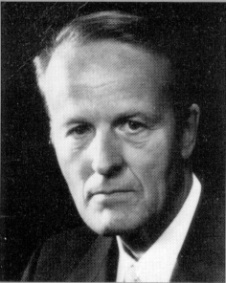

Professor Dr. Ph. D Werner Schiebeler

Elves, fairies, dwarfs, do

they exist in our world?

Werner Schiebeler, Physicist, Professor, Dr. PhD, born in Bremen in 1923. Studied physics in Göttingen and in 1955 graduated from the Max Planck Institute, Göttingen with his thesis on fluid dynamics. From 1955-1965 worked in the electrical industry at Standard-Elektrik-Lorenz AG in Pforzheim, seven years as head of a development department for electronic teletext technology. From 1965 lectured physics and electronics at the then State School of Engineering, now University of Applied Sciences, Ravensburg-Weingarten. Appointed professor in 1971and retired in 1983. In addition to the subjects of natural-science and technology, he also taught para-psychology and para-psycho-physics from 1969 onwards at regular special lectures at the University of Applied Sciences, Ravensburg-Weingarten and continued to do so the ensuing years.

The author published numerous articles in journals as well as brochure and four books on various para-psychological topics. In addition, he also released a film about the “Paranormal healing methods in the Philippines” at the Institute of Scientific Films in Göttingen. He received the “Ernesto Bozzano Price” from the Associazione Italiana Scientifica Metaphysica in 1974 and the “1st Swiss Price” from the Swiss Foundation for Parapsychology in 1988.

When talk turns to elves, fairies and dwarfs everybody thinks immediately of fairytales and sagas wherein these beings are mentioned. The most well-known is probably the leprechaun from Cologne or from Ireland. The Brockhaus Encyclopaedia has this to say about this:

“Elves, singular elf, are figures of light in German mythology and fairy-tales, beings somewhere between human beings and gods, in charge of earth, water and air. North mythology differentiates between beautiful, friendly elves of light and ugly, evil elves of darkness that dwarfs belong to. Other types of elves are water nymphs and house spirits. The concept of an Elf King is found in the name of Alberich (-rich = king) and also in the name Elverkonge in Danish folk ballads, something Herder understands to be Ellerkonge or Erl-king.”
A book dealing with “German folk tales” (Magnus Verlag, Vienna o. J) mentions in the chapter titled “The Elves”:

“In the lakes and rivers of the North Sea coast, around Friesland and between the mouth of the river Elbe and Helgoland, one often encounters floating egg shells. These are used by elves to move around. They are small, delicate elementary spirits, some are of a positive and some are of a negative type. They live in the water and they often come to the surface in bubbles in ponds devoid of fish, but they also live in small hillocks. These hillocks are called Alvinen hills in Brabant, as the old word of Alf, Elf has changed into Alfin, ergo Alvinne. As small as elves might appear, their power on the other hand is considerable. This is indicated by the great, powerful stream in whose delta they live and that carries their name, namely Elbe. Therein lies a deeper meaning, whereby the mightiness of the nature spirit expresses the ancient mystical wisdom inherent in runic magic in the German language.”

German fairytales usually depict dwarfs as helpful creatures (See brownies). The fairytales of the Brothers Grimm for instance mention the gnomes of a poor shoemaker who was able to observe the gnomes completing his jobs during the night, jobs he started during the day. The wife of the shoemaker made tiny little clothes for these creatures to thank them for their help and she laid them our for them in the evening as a reward. The hereto naked gnomes gladly wore these items of clothing and the fairy-tale goes on the say:

“They jumped and danced, leapt over chairs and benches. They eventually dance right out the door and they never came back. The shoemaker however fared well for the rest of his life and he succeeded with everything that he undertook.”

Historical bits of truth can often be found in legends and fairytales even though they have been fabulously embellished in folk tales. Is this also the case with elves and dwarfs?

One often encounters people that assert that they have seen or observed small, non-terrestrial beings once or some of them even numerous times in their life. Some say for instance that they have taken up lodgings in their garden. I know a few of them, particularly three, that are psychically highly gifted and can not only observe such elementary beings but also visually perceive deceased people at certain times.

In one case, elfish-looking beings could actually be photographed. And this happened as follows: An Englishman by the name of Edward L. Gardner, parapsychologically experienced and also interested in paranormal photography, received two photos in the mail from a friend (3, P. 15). These showed images of elves (Image 1 and 2).

In an accompanying letter, his friend asked for Gardner’s opinion. This friend had mentioned elves at a presentation and a woman approach him after and asked him whether he really thought that elves existed. This woman said that if he assumed this, the two photographs that her daughter had taken could possibly be genuine, even though she and her husband had not believed that they were.

These photos didn’t initially seem very believable to Gardner and he answered that it would be impossible to verify their genuineness without the negatives. Gardner held the opinion that he would never hear anything more about this case.

A few days later, he received two plate negatives from a Mrs. Wright from Cottingley, near Bradford, with the explanation that her daughter Elsie had taken these photos in a ravine near their home. This letter didn’t contain any further information.

Gardner took the negatives to a photographer named Snelling who had been recommended to him because he was an expert in photomontage (Photographer and Enlarger, The Bridge, Wealdstone, Middx.) He examined these plates in front of Gardner and his assessment on the 31st of July 1920 (3, P 18) was as follows:

“Negatives of images of elves. The two negatives are perfectly genuine, unadulterated photographs that have only been exposed once. They are open air pictures that show movement amongst all the elves. There are no apparent signs of studio work including paper and paste models, dark background, painted figures etc. Both of them represent genuine, unretouched photographs.”

Gardner’s next step was to have the negatives examined by the Kodak Company. The experts there expressed the following opinion:

The negatives have only had one exposure and show no signs of retouching, photomontage and the like. But this cannot be regarded as conclusive evidence of their genuineness. These images could somehow have been produced fraudulently, but this would have been very difficult and complex. For instance, one would have to photograph the girls in front of the background, enlarge the image, paint the elves by hand and then photograph everything once again.

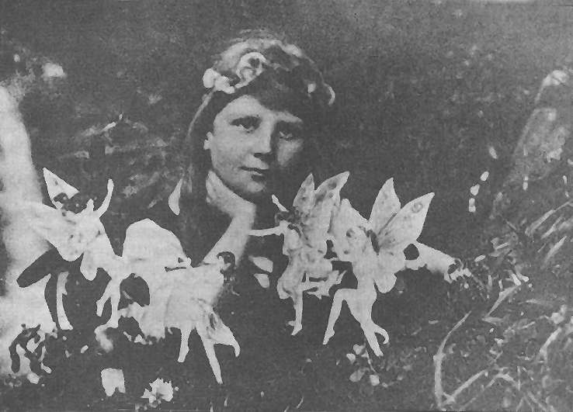

Image 1: Frances and the elves. Recorded by Elsie in July 1917. Distance approximately 1.2 m, exposure 1/50 sec. a sunny day, recorded in a ravine. A waterfall and rocks are at a distance of 6 m. The girl stand in shallow water near the bank of the creek. The girl described the colours of the elves as hues of green, lavender and bright violet (mauve), mainly spread across the wings and gradually fading to an almost complete white towards the limbs and the clothing.

Gardner’s next step was to drive to the Wright family in Cottingley near Bradford and he was told the following story: In July 1917, the sister of Mrs. Wright, a Mrs. Griffith and her ten years old daughter Frances lived with the Wright family. The Wright’s also had a daughter, she was called Elsie and she was 13 years old. These two girls spend most of their time in a ravine behind the house. They constantly talked about elves that they encountered and played with in the ravine.

The parents thought that it was only their imagination and they teased the girls about their elves. Elsie eventually suggested to her father, he was the administrator of a small land holding nearby, to lend her his camera so she could take a photo. The father initially laughed about this because he didn’t want to waste a photographic plate. Succumbing to the pressure from his daughter, he explained the handling of the camera to her and send her on her way.

The girls were back within less than one hour.

The father developed the plate that afternoon and saw the image (1). He and his wife did however not think that the picture was genuine and whilst the girls were somewhere else, search their room and the ravine for remnants of paper, because they believed that the figures had to be drawn by them. But they didn’t find any such things.

The girls took the second picture in September 1917 (Image 2). The camera was no longer lend to them after that and the negatives were put aside in a cupboard.

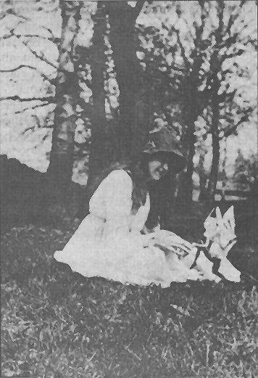
Image 2: Elsie and the gnome (Dwarf). Taken in September 1917 by Frances at the edge of a ravine. Elsie played with the gnome and beckoned it to sit on her knee. Frances pushed the shutter release the very moment he jumped onto her knee. The gnome wore black trousers, a reddish jacket and a pointed gleaming cap. The wings were like those of a moth and of a soft, neutral colour. Elsie said that the gnome had no perceptible weight when it stood on her naked hand, but that she felt something akin to a soft breath or whiff when he jumped onto her hand.

Gardner then went to the ravine with Elsie and she showed and explained the locality to him. Her cousin Frances was then no longer present. One decided to attempt to take further photos. To do this they asked cousin Frances to spend her holidays in Cottingley in August 1920, and the girls, now 13 and 16 years old, were asked to take new pictures. Two new, good cameras were purchased for this and two dozen plates also. The plates were marked in the darkroom by the camera shop owner a priory with a sign that only he knew.

Due to the extremely rainy weather only three pictures could be taken during the fortnight’s holidays (Images 3 to 5). They were once again greatly enlarged in order to discover traces of a paper or a canvas structure. But nothing like this could be found.

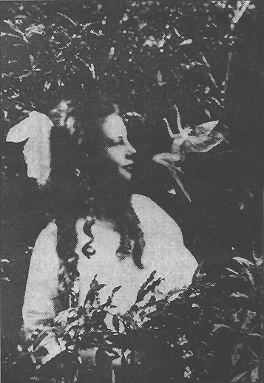
Image 3: Frances and the jumping elf. Picture taken by Elsie in August 1920. The elf jumped three or four times from the lower leaves whereby Frances was afraid that it might brush against her. This is why she pulled her head back a little. The light clothing seemed to be a tight fit. The wings were lavender-like.

The next year, in August 1921, further attempts at taking pictures were planned. Gardner asked a clairvoyant friend by the name of Hodson to go with him to Cottingley and observe the girls with the elves there with him. The three of them were able to make matching observations and they are printed in Gardner’s book. It came to pass that Mr. Godson was considerably more clairvoyant and more practised than the girls. He observed that the ravine virtually teemed with the most manifold forms of elementary life. He not only “saw” forest elves, fairies, gnomes, goblins and water nymphs, but also the rarer undines (water spirits) as they swam around in the creek.

Hodson for instance, describes forest elves that were observed on the 12th of August 1921 by three people (3, P. 37):

“Cottingley, in the forest under an old beech tree. Two tiny forest elves ran past us as we sat on a fallen tree trunk. When they saw us, they stopped for a moment at a distance of about five feet. They paused and looked at us extremely amused, but without fear. They gave the impression that they were completely dressed in a tight-fitting, one piece velum that seemed wet on the surface. Compared to the rest of their bodies, they hand large hands and feet. Their legs were somewhat thin, the ears large and pear-shaped and pointing upwards. Their noses appeared pointy and their mouths wide. As far as I was able to ascertain, they didn’t seem to have neither teeth nor other structures in there, not even a tongue. It seemed as if everything was made from a piece of jelly. They were enveloped, like an ethereal double in physical form, by a green light that was similar to a chemical vapour (Chlorine gas would look like that). When Frances appeared and sat down about a foot from them, they were startled and distanced themselves to a distance of about eight feet. They obviously observed us from where they had moved to and exchanged their impressions between them. These two live between the roots of a large beech tree. They disappeared in a crevice they traversed through like a cave and thereby sank beneath the ground.”

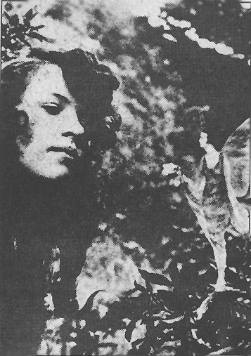
Image 4: An elf offers Elsie a small bunch of flowers. This picture was taken by Frances on the same day as image 3. The elf remained almost stationary and hovered over the blossoms of the flowers. The wings were of a yellowish iridescence. The children had been away from the house for around an hour and a half according to Mrs. Wright.

On Tuesday the 16th of August at 10 pm they observed the following under the light of a small photographic lamp (3, P. 39):

“Elsie saw a ring of elves that were tripping around in a circle with their faces turned to the outside. A figure then appeared in the middle of the circle. When this happened, the faces of the elves turned towards the centre.

A group of goblins, coming from the forest, ran towards them to a distance of 15 feet. They differed somewhat from the forest elves as they appear more like gnomes, even though they are smaller, about the size of brownies.

Elsie saw a wonderful fairy close by. She was naked, had golden hair and she was kneeling in the grass, she looked across to us with her hands on her knees and smiled at us. She had a lovely face and she concentrated her gaze on me. This figure approach us to within a distance of five feet and after having presented itself to us, it disappeared.”

Thus far a short excerpt from the more than seven pages of depictions by Gardner about the clairvoyant perceptions of Elsie, Frances and Hodson. Photographic images were not forthcoming that year. The required paranormal abilities of the two girls might possibly not have been sufficient any more. Clairvoyance is one thing and the ability to produce paranormal images another. They must not necessarily be coupled together automatically. Paranormal abilities tend to disappear when puberty begins. No more attempts at making photos were made in the years after, because Frances stemmed from South Africa and she did not return to England.

Gardner based his approach and his assessment on the proviso that the apparitions of elves were not made of flesh and blood and could therefore not be seen by everybody. But due to the psychic abilities of the two girls, they could be perceived by them clairvoyantly and even photographed. This type of photography is also called ghost photography.

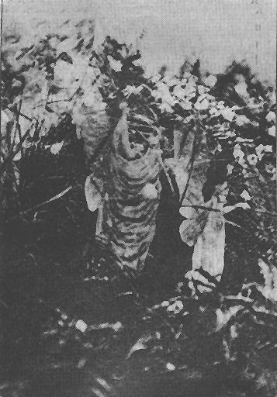
Image 5: The third picture taken in August 1920 was a fluke and it was taken on the bank of a little pond near the small creek. The girls noticed a movement and a figure in the long grass and simply push the shutter release. The girls had never seen such a cone-shaped shell with an elf in it before and they could not determine what it was. But this object in the matted grass was on the other hand impossible to artificially reproduce.

Soon after the invention of photography (Louis Daguerre 1837) it became apparent that psychically gifted photographers could sometimes also take pictures of the deceased, not specifically targeted deceased personalities, but quite often deceased relatives and unknown characters standing next to living terrestrial people being photographed. The first one to notice this “ability” was the engraver William H. Mumler in 1862 (died 1884). This characteristic also showed up with other so-called photo mediums.

Opponents of everything paranormal have almost always called this a deception (The images taken at Cottingley also), but the deception through photomontage was in almost all cases not possible. An example should explain this: During the years around 1935, a materialisation and spirit photographic medium by the name of Clarence Britton was active at the spiritistic Camp Wonewoc in the State of Wisconsin (USA). He was then a man in his late fifties. He had fixed a black cloth to an external wall and he sat the clients that wanted to be photographed in front of it. He generally didn’t know these clients at all. The faces of deceased relatives and acquaintances often appeared next to the faces of unknown personalities, after the photographic plates had been exposed and developed.

The teacher Lenice Quick from Fennemore in the State of Wisconsin allowed herself to be photographed in 1935 under these circumstances. The developed picture (Image 6) shows her surrounded by six other heads. The three heads below, from left to right, represent her deceased father, an aunt and her father-in-law. The three heads above belong to unknown personalities. The father and the aunt amongst them were rendered extremely clearly and were therefore easily identifiable by the teacher. The photographer had no opportunity whatsoever to obtain photos of the deceased, when they were still alive, from the unknown teacher beforehand. Besides, he photographed dozens of people per month and he would have required suitable pictures of the deceased of all of them. This is an impossibility and it shows how absurd the claims of fraud really were. Ever since 1962, thousands of such “spirit photos” have been produced by a most diverse lot of photographers and numerous amongst them have been published.

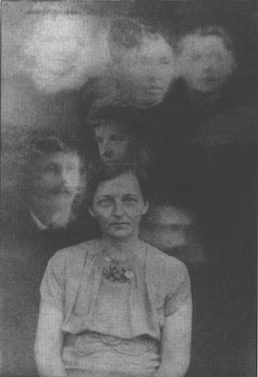
Image 6: Picture taken of the teacher Lenice Quick by the spirit photographer Clarence Britton showing six images of deceased personalities above her head. Below left shows her deceased father, to his right an aunt and next to her, her father-in-law, both of them also deceased. The three heads in the row above represent unknown personalities. Lenice gave this photo with explanations to a professor Walter Uphoff from Oregon who was also present at Camp Wonewoc. The author received this treatise from him

Back to the photos of elves from Cottingley. The first, major publication about this happened towards the end of November 1920 through the very well known crime writer Sir Arthur Conan Doyle in the popular magazine “Strand”. This case drew worldwide attention through this and it caused a lot of excitement, but it also drew the opponents of everything paranormal into the fray. During the following decades, right up to 1981, journalists and television station tried to get to the bottom of this by asking Elsie and Frances how they had managed to procure these photos. The sequence of events is elaborately described in the book by R. Krauss (6) on pages 191 to 193. Only in 1981 did the journalist Frances Jot Cooper succeed in hearing an alleged confession from the mouth of the now 77 and 74 years old Elsie and Frances, namely that they had drawn the figures of elves on solid paper, cut them out and fastened them to the grass with hat pins. A drawing in a book that was published in 1915 had served as a templet for them. This assertion is so adventurous and technically impossible that one can actually regard it as further evidence of the genuineness of the photos.

- Firstly, it is highly unlikely that two 10 and 13 years old children had possessed a recently published book of verses without their parents knowing about it.

- Secondly, small children cannot produce such complicated drawings of the quality these photos represent.

- Thirdly, the photos would have to show some creases or crinkles of the paper, because paper cannot be erected absolutely smooth in the open air.

- Fourthly, it is completely impossible to attach the only relatively stiff paper figures in the open air with hat pins. The parent had indeed searched the rooms of the girls for remnants of paper and found nothing. Such elaborate drawing cannot be produced within half an hour without leaving remnants of paper laying about.

- What would be the reason for the children to do this in the first place? To annoy or to fop the elves? They could not foresee that half the world would hear about it at some stage.

These alleged confessions were disseminated worldwide in spite of their absolute incredibility and technical impossibility, they were believed and they were even published in parapsychological journals. The German magazine Esotera published an article in issue 5/1983 under the title: “The elves of Sir Arthur Conan Doyle. A 76 years confesses a youthful escapade with falsified photos of elves.” This enticed me to write a letter on the 19th of May 1983, with the relative photo material, to the editor of Esotera wherein I exposed the alleged confessions as being utterly inapplicable. My letter to the editor was printed in abridged form in issue 6/1983, but without the essential photo and not in an as prominent position as the previously presented “confessions”. Even people that look favourably upon parapsychology these days think that the Cottingley photos have been debunked as falsifications a long time ago. Nobody takes the trouble of reading and testing the original literature to see whether a falsification in the alleged fashion was actually possible in those days.

Arthur Graf Seherr Thosz reports about another experience with gnomes in Psychischen Studien (the leading German parapsychological journal of the previous century). XVI January issue 1889, P. 16:

“The deceased Baron Balassa, who owned the castle and the dominion Köke in Hungary, was a man with an extremely phlegmatic temperament. He particularly liked to deal with his books. The library of the castle was his favourite place. Balassa often visited me whilst I resided with my family on the shores of Lake Geneva in the days when he had also established a place of residence there. During that time, he often talked to me about the little grey manikin he had seen in the library on many occasions. The manikin was hardly three feet tall (ergo about 1 m), had an old face and wore medieval clothes. This gnome jumped from one of the walls or one of the book cases, walked around the room a quarter of an hour at a time without taking any notice of Balassa, to then miraculously disappear again the way he appeared. Balassa never tried to talk to him. In his phlegm, he did not allow this droll apparition to interfere with his reading.”

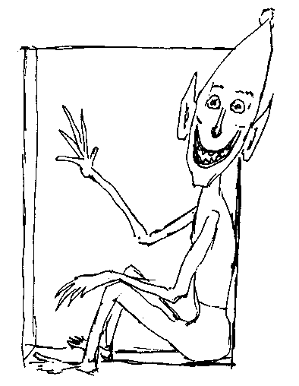

This example fits in well with the footprints that I examined in my painting workshop, because they ended at the wall. The creature that left these tracks behind must have either dissolved in thin air or it must have walked through the wall.

Reports about elves and gnomes come to us at times from the world of the hereafter. In 1965 and in 1979, the Christian Spiritualistic weekly journal of the Geistige Loge Zürich, “Geistige Welt” publisher Arthur Brunner, published lengthy treatises about spirit beings that manifested themselves through the Medium Beatrice Brunner (1910 – 1983) and reported about the realm of elves. A spirit entity who called herself Lene gave the following narration on the 20th of October 1965 and I reproduce extracts from it below (Geistige Welt no. 48, P. 382):

“We found that you are pleased and particularly interested when one talks to you about another world, I mean the realm of gnomes, elves and fairies. You know relatively little about these nations of little spirits. We try to enlighten you a lot more, because it is of use to your soul. We want to give you insights into the world of spirit and you should also receive information about life in this divine sphere.

Well, gnomes, elves and fairies are three different groups and they are also subject to different level of development. I already explained that they also participated in the Fall from Grace, but this doesn’t mean that all of these little creatures have fallen from Grace and must now participate in the ascension. We are only dealing with a fraction of them. A lot of these glorious fairies and elves also exist in God’s world on various higher levels and this also applies to gnomes: All of them probably look different from the way you imagine them to look.

I would like to describe these gnomes to you. This nation of gnomes – this is what I like to call it – is on the one hand very obliging, but on the other hand very quarrelsome amongst their own kind. They place themselves in the service of human beings, you will hear why this is so later, but I would like to talk about the peculiarities of their life to begin with. They can be found in forests, barns and numerous houses, well, this isn’t quite true, they rather select the houses whose inhabitants they like. They never stay where people are abhorrent to them. They are therefore in the forests, with animals, in stables and barns, in open fields and the mountains. They are also on the water, in gardens and in bushes. They also have their own accommodation, something they build for themselves according to the taste that they possess. Some of them are demanding whilst others are modest. They perform tasks for people and animals that the higher world of spirit assigned to them.

I will now tell you specifically about elves. They are created differently. Whilst gnomes do not look particularly beautiful, they do indeed wear very colourful clothes. Gnomes like colourful things. Fairies, on the other hand, are created differently. They differentiate from elves as well as gnomes. Elves prefer particularly beautiful gardens. They would certainly not stay in a barn, because – they say – that they are not born to live there, they say that they are too posh for this. They are indeed very beautiful, but very hard to describe with your conceptualities: They are delicately structured, small of stature and everything about them is noble.

This nation of elves also has its assignment. Elves also prefer very specific locations. They utilise a very special type of od-stream. They feel most comfortable where flowers spread their fragrancies. They love all flowers, the flowers in the fields and the flowers in well-kept gardens as well. They also stay in greenhouses. They love everything beautiful and they claim that they were only born to be amongst beautiful things.

These elves make music with the little instruments and thereby bring joy to lots of creatures. They bring pleasure to the world of small animals. They play their music in the gardens they selected for themselves. This is where most of them build their own abodes. Once the pleasant season comes to an end, they flee from the atmosphere that has become unpleasant to them and they look for other places, places they find pleasant to live in, places where their delicate, fragrant and exhilarating clothes fit the atmosphere.

Elves that love children often go to children’s playgrounds to stay there. They also visit ill children in their rooms and if flowers are present, they make their home in these colourful bunches of flowers. They almost certainly have their little instrument with them so they can play their music for the child that’s ill. Well now, this music can only ever rarely be heard by the child. But some small children are still connected to the previous spirit life some degree and they can hear this delicate music and also still perceive these little creatures. This however only happens on very rare occasions, but these elves do fulfill a task in regards to ill children.”

This is only a small extract from the very copious narrations by the spirit being called Lene.

I began by reporting about people that could perceive elfish or gnomish (dwarfish) beings once or numerous times. I deliberately say “perceive” and not “see” in a terrestrial-physical sense by means of electromagnetic light waves. These beings, if they do actually exist, are not members of the coarse material world, but belong to a different form of existence, one that we can even photograph in special cases.

But there are people that can perceive elves all the time. They dispose over a special gift that we call clairvoyance or exceptional sensitivity. A healer by the name of Dora van Gelder, who lives in the USA, is such a sensitivity. She wrote a book (5) about her ability and reports therein (5; P. 14):

“A lot of people are willing or even yearn to believe in the existence of elves. These little beings are so tightly linked with the happy memories of one’s childhood, that one gladly looks back on a less material world. But they do constitute a lost paradise for most of us; fortunately, not for all of us. I have been able to perceive nature spirits for as long as I can remember and I continue to see them every day. A lot of people fare the same as I. When I say see, I mean that they are around me like trees and that I perceive them as objectively as I perceive them.

I will try to demonstrate the reality of this wonderful beings to you on the following pages. It might be best to explain to begin with why I possess a number of favourable prerequisites in regards to this. As I grew up in the Far East, nobody discouraged me in regards to my observation of the realm of elves, because a lot of clairvoyant people are to be found there – and lots more that believe in elves. The gift of clairvoyance, not that unusual to children, has been preserved for me for this and other reasons. I was also fortunate enough to have been born into a family and to have had friends that also disposed over this ability. Everything that I committed to paper in this book is therefore not the fantasy of an isolated child. We are dealing with information that I received through lots of contacts and conversations with nature spirits from all over the world, they came about under natural but somewhat unusual circumstance.

One can communicate with these beings almost the same as we human beings communicate – almost the same. The method, I would like to describe in a few words, differs only slightly from our way of communicating, it happens faster that language and to some extent represents a direct exchange of thoughts.

To mention these things is important. When we look at the world through the eyes of elves we find that vista of a new universe opens up. A lot of the things we attach importance to appear meaningless to them. Life and death are normal actualities to them and this has nothing to do with uncertainty or tragedy. People generally avoid life and fear death. Elves on the other hand utilise the life-energy found in all things. We live in a world of physical matter without ever grasping the life-force that’s behind physical matter. We equate the loss of form with the end of life, but elves see this entirely different. They are able to give us a vigorous and memorable lesson.

Why are most people not able to perceive elves?

Elves live in the same world that we live in, but their bodies are less dense than our own and finer that the finest substance. Because the veil between us and them is extraordinarily delicate, so delicate in fact that almost everybody should be able to penetrate through it with just a little effort. The difficulty consist in showing the path to this and above all, to make it comprehensible to others. The most important reason why it evades the general perception of people probably lies in our different points of view. If my accounts make a contribution towards changing people’s opinion in favour of the realm of elves, you will find that these changes will enable people to perceives elves to an ever higher degree.

This naturally doesn’t cover everything.

A specific sense must be developed if people want to see elves. The world that they live in is not accessible with our ordinary perception capabilities. One can neither touch them nor feel them, but certainly see them. Our normal capability of seeing things does indeed represent an aid, but it is however not developed enough to perceive them and the light that they emanate. All of us do however possess the latent talent of seeing ethereal things and a number of people have already been successful – an astonishing number of people actually – in unfolding it. The higher developed perception capabilities make it possible to observe the characteristics of the realm of elves. All of us possess a distinctive ability to see things. We touch solid forms; our sense of taste gives us information about fluids and our sense of smell allows us to notice fragrances and odours. Our eyesight is more subtle, but that’s not all. These exists a special form of seeing, one that is called clairvoyance – clear sight.

Dora van Gelder continues a few pages later (5, P. 18):

“In regards to my own situation, I am able to see elves. I also see them with closed eyes. But I generally do not close them, because it is superfluous to do so. Besides, my normal ability to see things helps me to see details. – I would like to state that the lots of different kinds of creatures and activities exist within the invisible world besides elves. It is however not my intention to report about other creatures in this book. Some of them are however so closely connected to the life and activity of elves that I will mention them in due course.

I must therefore explain that two important life forms exist in regards to elves and they represent a part of nature’s realm.

Elves are indeed a part of a great evolutionary line that runs parallel to the evolutionary line of human beings. It begins, as is also the case with the evolutionary line of human beings, with a few primitive forms that then develop into elves that also occupy various levels of evolution. The highest entities amongst them are those that are traditionally called angels – or devas. Elves have the same kind of relationship to angels, to a higher or lesser degree, as animals have to human beings. Almost all elves and a lot of angels are concerned with the processes of nature.

(5, P. 56) The emotional level predominates with elves. They mostly direct their attention instinctively to the things that are within their area of responsibility. Feelings instead of thinking play a role in their life. Their whole world – and naturally the substance of their bodies – is energy and feeling instead of logic and form. Whilst we occupy ourselves with form and the control of physical things, feeling are number one in their life. One can generally say that they display positive feelings, but an elf might at times be rebellious and refuse to work or quarrel with its neighbours.

(5, P. 57) Elves are not tied to a specific location or garden; they change location now and then. This is something that comes natural to them and it is also simple. The owner of a garden that loves his trees and plants and eventually also develops a feeing for their inner life, attracts a lot more of these little creatures than someone that is indifferent to these things.

All elves like small children, young rabbits, cats, fish or trees. Youth exercises a specific attraction on them; they feel connected to it with sympathy and the joy of life. Children and all small, young beings and creatures act with an open mind towards elves.

Elves like small children, they observe them with interest and delight and they even try to imitate the games they play. The same applies to young game and young rabbits. They are protected by elves and I think that a lot of these critters are able to perceive them, because they are closer engaged with nature than us and their ability to perceive things has not yet been dulled.”

In numerous chapters titled “Earth elves”, “Garden elves”, “Tree elves”, “Mountain elves”, “Water elves”, “Fire elves” and “Air elves”, Dora van Gelder describes the various looks and characteristics of the various types of elves. She writes about garden elves for instance (5, P. 74):

“Forest and garden elves are the most important types amongst the beings that inhabit the surface of the Earth – and tree spirits can also be counted amongst them. In order to gain a little more insight into their special characteristics. it would probably be best to describe the members of each individual group, namely the characteristics of garden and forest elves.

There are various types of garden elves. The smallest amongst them have the form of a candle and they look rather feminine. They can be between 22 cm and 30 cm tall whereby the head is rather long. There, where we usually find the flame of the candle, we find a human face. The body is of a bright apple-green colour and the face is brownish. They have well-formed legs and feet. These elves look after small plants and flowers that grow in garden beds, like lobelias for instance, and they look after small plants that grow in clusters. They hardly ever react to other creatures or events that take place outside of their immediate surrounding. They display simple emotions, but they are capable of feeling affection for their plants or jealousy in regard to one another. They have a desire for new impressions, because this gives them the best opportunity to learn. One can see them hover around in all beautiful gardens in groups of three or four.

We find elves amongst tulips and related flowers that are about 30 cm tall, they look more like human beings than the “candle elves” and their contours are enveloped by a delicate purple colour. Some of them have, like fawns, delicate, long faces. Due to the smallness of their stature their similarity to human beings is not all that pronounced. Due to their thinness, one would rather think of a caricature. Their limbs can be compared to those of human beings, but the incompleteness of their hands and feet is quite apparent. One can observe a plurality of fingers and toes and their hands are sometimes like the paws of little kittens. Their form is surrounded by a permeating, phosphorous substance of a beautiful and delicate purple-coloured hue.

The garden that is mentioned here had a number of beds of beautiful pansies. Lovely, delicate butterfly-like beings hovered around them. They were minute, only a few centimetres tall and their faces looked almost like those of the pansies. Their shape of their body reminded one of butterflies or dragonflies. It was torpedo-like in shape and smaller than the face. The body and head combined were around 10 to 12 centimetres long whereby the head was 3 cm long. Two wing-like contraptions protruded from the neck and they stretched the length of the body, they did however not fulfil the function of wings, they only had a decorative purpose. The body and face were flesh-coloured in delicate violet and purple hues. The wings were of a similar colour and they were colourful and shiny. Living as a community plays a role in the invisible and the visible world and wherever one finds a flower bed, one not only finds butterflies, but also elves. – (5, P. 77) I came across elves of the butterfly type in a small, glassed greenhouse and they were 2 to 5 cm taller than the others of their type, they were human-like, but didn’t display any other differences.

These butterfly elves had, after having lived in the greenhouse for a certain period of time, apparently specialised in accelerating the grows of the plants there. They are delicate and ethereal beings.”
Thus far the extracts from the expositions of the sensitive Dora van Gelder. The benevolent, but initially sceptic reader of these reports should allow then to gently settle in their mind and compare the various accounts with one another. I thank that they complement one another without contradictions. The girls from Cottingley photographed winged elves and Dora van Gelder describes the same kind of elves. Beings with thing arms and legs and with pointed hats appear in all of these descriptions.

One cannot sweep aside the pronounced perceptions of numerous people throughout the ages as figment of their imagination as far as I am concerned. We must acquiesce to the fact that there isn’t just an ethereal, beyond-death world next to our coarse physical world, but that a world of nature spirits exists next to our world that remains invisible to most people.

* * * * * * *

Reference

(1) E. Bäzner: "Die Naturgeister", Drei Eichen Verlag, Munich
- A. C. Doyle: "The Coming of the Fairies", Publisher Hodder and Stoughton, 1. Edition 1921, later Publisher Samuel Weiser, New York 1972
- E. L. Gardner: "Fairies, The Cottingley Photographs and their Sequel", The Theosophical House London Ltd, London 1945
(4) E. L. Gardner: "Elfen, Fotografien von Naturgeistern und wie sie entstanden", Ansata Publisher, Interlaken/Switzerland 1979 [Edition in German of (3)]
(5) D. van Gelder-Kunz: "Im Reich der Naturgeister", Aquamarin Publisher, 3. Edition, Grafing 1995
(6) R. H. Krauss: "Jenseits von Licht und Schatten. Die Rolle der Photographie bei bestimmten paranormalen Phänomenen - ein historischer Abriss", Jonas Publisher, Marburg 1992

This type of angel should however nit be confused with the angels in the Christian-religious sense that appear to us human beings as direct messengers of God. The angels or devas mentioned here are otherworldly beings that can be either good or evil or indifferent. They specifically play a role in Hinduism.

