PSYCHO-SCIENTIFIC FRONTIERS

Selected publications from a variety of subjects of psycho-scientific research. Editor: Rolf Linnemann (Certificated Engineer) * Steinweg 3b * 32108 Bad Salzuflen * Tel. (05222) 6558

Internet: http://www.psychowissenschaften.de E-Mail: RoLi@psygrenz.de
Translator’s email: evak30@optusnet.com.au

Extract from the journal “Border areas of Science”, Booklet 47 1998-1.

Theme : The battle over materialisation phenomena

Author : Professor Dr. W. Schiebeler

Editor : Professor Dr. P. Andreas Resch, director of the Instituts für
Grenzgebiete der Wissenschaft (IGW), Innsbruck (Institute for border areas of Science, Innsbruck)

“Border areas of Science” is an inter-disciplinary quarterly journal for the border areas of science of physics, bios, psyche and pneuma, about their legalities and spontaneity, about evidence and life experiences, immanence and transcendence.

Preface

So-called materialisation phenomena caused an immense sensation and equal contrariness when they first gained prominence from about 1850 to 1950. If they had been accepted as being genuine, they would have resulted in far-reaching implications for science, philosophy and religion. But according to the maxim, things that should not be cannot be, mediums and investigators must therefore have been swindlers, imbeciles or charlatans. But those that ardently and unprejudiced study otherworldly research reports must recognise that honourable and eminent researchers observed, photographed and documented actual processes of nature without hallucinations, namely the temporary paranormal creation of human-like forms (Phantoms).

If these results do not fit into people’s view of the world, they must naturally be hushed up.

They will then never have happened!

Bad Salzuflen, August 2000

1. The nature of materialisations

Amongst the physical apparitions within parapsychology, so-called materialisation phenomena have always aroused the greatest sensations. One is dealing with the temporary, paranormal creation or formation of strange substances that are called teleplasm or ectoplasm. Tissue, veils, images or human limbs (arms and legs) and completely constructed human bodies with breathing and circulation capabilities (audible heartbeat) can form from it. The last mentioned entities are usually called phantoms (apparitions). They declare to be deceased people that are supposed to have lived on Earth in the past. These processes were so impressive and for our natural sciences and our religious view of the world so momentous that they were branded by critics and disbelievers right across the board as a swindle and “modern” animistic minded parapsychologists completely ignore them these days.

When Munich neurologist and parapsychological researcher Albert Freiherr von Schrenck-Notzing published a comprehensive work about “materialisation phenomena” in 1913, he immediately expected considerable attacks on his work and therefore wrote in the preface of the book amongst other things:

“Dealing with the discredited subject of so-called ‘spiritual apparitions” still results in certain disadvantages for the relevant researcher. He isn’t only accused of being devoid of observation capabilities, critical prudence and credibility, thereby exposing himself to ridicule and the accusation of ‘charlatanism’, as for instance the late criminal-anthropologist Lombroso, he also risks the danger of being accused of being mentally deficient, if not outright mentally deranged, something that happened to the astronomer Zöllner and the English physicist Crookes”

Schrenck-Notzing was in indeed severely attacked after his book came out, that is to say, the apparitions observed and described by him were declared to be clumsy tricks and swindle. The physician Mathilde von Kemnitz, nee Spieß (1877 – 1966) was particularly vocal amongst his detractors. Her second marriage was to General Erich Ludendorff, former German First Quartermaster General in WWI. She was later the main driving force behind the so-called Ludendorff-Movement during WWI fighting against Freemasons, Jews, Jesuits and Marxists. In his book “Der Kampf um die Materialisationsphänomene. Eine Verteidigungsschrift” (The Battle against the Materialisation Phenomena) a defence statement published in 1914, Schrenck-Notzing extensively dealt with her and refuted her incorrect assertions.

What are we actually dealing with when it comes to paranormal materialisations?

The apparitions that are “formed” are not created from nothing as far as we know, but extracted from our physical environment, preferably from the body of the medium that is present. This extraction takes place as a clearly visible stream from the body of the medium and it has often been photographed. The substance that becomes visible and tangible in the process is called “ectoplasm” or “teleplasm” most of the time. From the numerous photographic pictures of this process disseminated through literature I have rendered two of them here to begin with.

The first image shows the English deep-trance and materialisation medium Jack Webber (1907 – 1940) sitting on a chair like being pinioned by a trance. A broad veil of ectoplasm streams from his mouth. The ectoplasm observed and photographed streaming from him was up to five metres long. The second image shows the Danish medium Einer Nielsen. He is also in a trance. A gauze-like substance, ectoplasm, flows from his mouth. Its structure was usually denser than the one produced by Jack Webber. It could also extend to a few metres, separate from the mouth, carry out independent movements, as the third image shows, and form into a human shape for a short time.

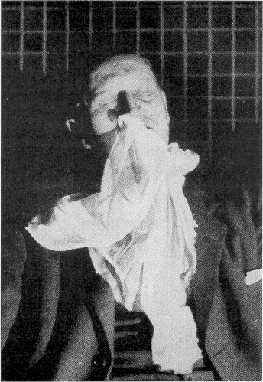
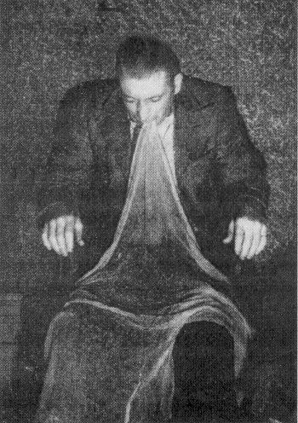

Image 2: Ectoplasm streams from Einer Nielson’s mouth and nose whilst in a deep-trance. Picture taken in the presence of Dr. H. Gerloff, 17-1-1953. (From H. Gerloff: The phantoms of Copenhagen. A picture book P.38)
Image 1: Jack Webber in a trance tied to a chair with gauze-like ectoplasm streaming from his mouth. Picture taken January 1940. (From H. Edwards: The Mediumship of Jack Webber, Plate 31)

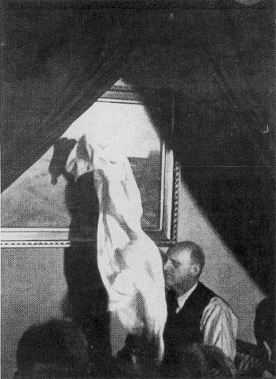

Image 3: The ectoplasm has separated from the medium Einer Nielsen and is carrying out independent movements. Such a phantom form can create itself within seconds.
(From H. Gerloff: The phantoms of Copenhagen. A picture book, P. 45)

Opponents and critics of parapsychology always asserted that, with Nielsen also, the production of such ectoplasm had actually been normal gauze that the medium had either swallowed before to then regurgitate after or hidden in the anus to then be pulled out during the session.

In order to confront such assertions, materialisation mediums were orally and rectally examined prior to such control sessions, Einer Nielsen also. Other mediums were tied to their chair during the course of the following sessions (for instance Jack Webber) whilst others were clothed in special garments that were sewn up at the neck. The production of ectoplasm continued in spite of this and also disappeared back into the body of the medium after.

Image 4: Einer Nielsen (1894 – 1965) Image 5: Albert Freiherr von Schrenck-Notzing
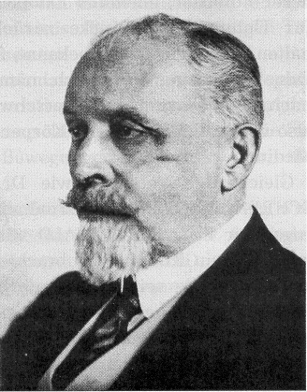
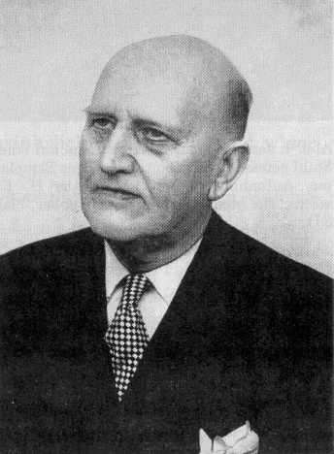
(1862 – 1929)

A neurologist from Munich, Dr. v. Schrenck-Notzing (Image 5) however went one step further with his investigations. In January/February 1913, June into August 1913, February 1914 and July/August 1916, he examined a young Polish girl by the name of Stanislawa P. born in 1894, cashier at a store in Warsaw. Ectoplasmic substances also flowed from her mouth.

During the examinations in the summer of 1913, the medium was completely stripped before every session and then dressed in a black tricot that enveloped her whole body. In addition to that, her head and mouth were covered with a veil that was attached to the tricot. No purely mechanical, ergo physical, fraudulent gauze substance could either enter or leave through this raiment. Ectoplasm flowed from the mouth of the medium through the undamaged veil in spite of this.

This process was also photographed by Schrenck-Notzing on the 1st of July 1913 and this with three cameras simultaneously from the front, the right and the left side. Image 6 depicts one of these photographs. On can recognise the black face veil of the medium and the ectoplasm flowing through it.

On the 25th of June 1913, this event was also filmed and it included the escape as well as the flowing back of the ectoplasm. Schrenck-Notzing published pictures taken from the film in his book. One can see from them and from the conducted examination with absolute clarity that the ectoplasm-phenomenon is not a trick, something its opponents have always asserted.

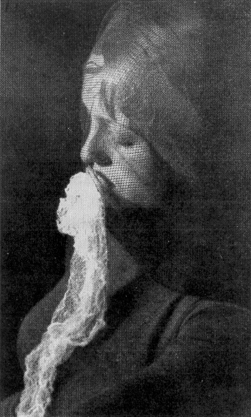

Image 6: Ectoplasm flowing from the Polish medium Stanislawa P. The ectoplasm flows through the face veil. One of three simultaneously taken photographs from three different directions by Dr. A. v. Schenck-Notzing in Munich on the 1-7-1913.

(Taken from A.v. Schenck-Notzing Materialisation Phenomena, plate 139, Image 215)

On the 20th of February 1916, Polish researcher Liebiedczhinski succeeded in capturing a small piece of this ectoplasm in a sterilised porcelain container before it disappeared back into the mouth of Stanislawa P. and had it medically-biologically examined at two institutes for medical research. The sample had a diameter of 10mm, was 5mm thick and weight 0.101g. It looked porous, yellowish white, glossy and was odourless.

The tests established that one was dealing with a kind of albumen substance allied with fatty substance and cells, the kind we find in human organisms. What was specifically conspicuous was the large presence of leucocytes, amounts one never finds in sputum for instance. The substance had a strong resemblance to lymphatic fluid within the human body, but without actually being identical to it. It was indeed an organic substance, presumably extracted from the medium’s body.

Endeavours by other researchers to also capture ectoplasm for examination purposes have failed as far as I am aware. Ectoplasm usually dissolves after such attempts, it assumedly disappears back into the body of the medium.

Engineer Frits Grunewald undertook similar experiments to Dr. v. Schrenck-Notzing with Einer Nielsen. Grunewald moved large sections of his laboratory for parapsychological research from Berlin to Copenhagen. His observations took place in the presence of neurologist Dr. Krabbe and physicist Professor Christian Winther from the 15th of September up to the middle of December 1921. They ended up conducting thirteen sessions during that time.

From the fourth sitting onwards, Nielsen underwent a thorough physical examination before and after every session so that he could not bring any substances or objects for deception purposes with him.

From the ninth sitting onwards, Nielsen was dressed in a special tricot with an attached hood and with gloves made from velum. But white substances, ergo ectoplasm, escaped from the mouth of the medium through the undamaged veil in spite of this.

During the twelfth session, Nielsen, having been sewed into his tricot, was also placed into a “cage” with walls made from tulle so that no outsider could have handed him a veil. As before, the examiners could once again observe a veil hanging from the mouth of the medium that reached down to his lap. The illumination was provided by a red-light lamp of 100 Watt and the scene was photographed with five stereo-cameras.

- With such caveats in place, they make any deception impossible, all critics would have to remain silent. But they do not do so and they simply ignore such tests. They maintain to this very day that all of it was just a trick.

Based on today’s level of knowledge one has to regard ectoplasm (or teleplasm) as the substance “materialisations” are based on, this applies to the “phantom limbs” of the materialised “human limbs” that were able to exert force and cause movement and other “phantom forms”.

The following is important in regards to the question of where the physical energies come from that are required by the various transformation processes: Not only the medium but sometimes also the rest of the participants felt extremely exhausted after some of the experiment sessions. This could be a sign that not only physical matter was drawn from them for these processes, but also energy. Some of the meetings were accompanied by a lowering of the temperature during paranormal processes (telekinesis and materialisation) that was clearly felt by those present. I myself have also experienced this during telekinetic experiments. The lowering of the temperature could have been the result of the withdrawal of energy to procure these paranormal experiments. These are however only hypothesis’s at this stage. Exact measurements of these apparitions are presently not available.

Image 3 shows the ectoplasm expelled by the Copenhagen materialisation medium Einer Nielsen separate from him and to independently move around in the room before piling up into a preformatted phantom. A perfectly formed human shape, a full-phantom could develop from this within seconds. A great number of them could be observed with Einer Nielsen. One estimates that one is dealing with around 17,000 of them during the course of 47 years. With Nielsen, these ectoplasmic phantoms had a perfect human shape most of the time. They displayed a heartbeat, a pulse and normal breathing. One could also have a flowing conversation with them. These were beings that had a terrestrial body for a limited time, for the duration of a few minutes to a maximum of one hour.

I my books “Death, the bridge to a new life” and “Testimony to the otherworldly world” I extensively dealt with the processes of materialisation sessions with Nielsen and other mediums and I included numerous images of phantoms.

Image 7 shows one of the phantom images taken with Nielsen. It depicts the late Swedish clergyman Martin Liljeblad (1877 – 1950) with a “materialised” spirit being to his right. The figure said that it had been a Danish Clergyman by the name of Christensen whilst on Earth. Liljeblad acknowledged that he was his deceased friend. The phantom emerged from an open “closet” standing in the corner of the room separated by a curtain and placed his hand on his colleague’s shoulder.

Image 7: The Swedish clergyman Martin Liljeblad (right) with the phantom of a deceased clergyman by the name of Christensen on the 20-5-1938 at Einer Nielsen’s in Copenhagen.

(From H. Gerloff: The phantoms of Copenhagen. A picture book, P. 63)
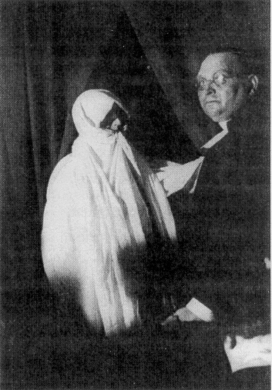

Dr. Hans Gerloff (1887 – 1967), the meritorious reporter, investigator and defendant of Einer Nielsen tested, amongst other things, the heartbeat and respiration of his phantoms, the latter by having the materialised form blow its breath into a bottle of calcium water (Calcium-hydroxide Ca)OH)₂ dissolved in water). The exhaled air caused a cloudy deposit of insolvable calcium-carbonate CaCO₃ on the completely clear liquid solution, evidence that the air exhaled by the phantom contained a high degree of carbon dioxide CO₂. The normal air around us contains only 0.03 volume percent and does not cause any visible deposit. The gas exchange taking place in the lungs of living human beings produces CO₂ in the air they breathe out (Inhalation of oxygen, exhalation of 4.5 volume percent of carbon dioxide).

Dr. Gerloff undertook this experiment with the phantom of the above mentioned Swedish clergyman Marin Liljeblad as he often materialised after his death in 1950 in Copenhagen. Dr. Gerloff describes the course of this experiment as follows:

“Liljeblad died well over one year after I visited him during the summer of 1950. During my first meeting with Einer Nielsen in Copenhagen on the 19th of January 1952 to observe materialisations, he appeared as phantom no. 16, told me his name and led me to the closet of the medium in order to hold the medium’s hand whilst placing his arm around my shoulders and kissing me on the temple. He wanted to show me that phantom and medium were two separate entities. He also embraced me during the second meeting so that his white teleplasmic garment enveloped me and he kissed my forehead.

During our meeting on the 18th of January 1953, he provided me with his breath through a straw into my tube of calcium water. When I was called upon to enter the closet and when I couldn’t orientate myself due to the darkness, his form suddenly lit up brightly. With the help of a highly sensitive hearing apparatus (Phone-endoscope) I proceeded to first hear the heartbeat of the medium and I ascertain that in his deep-trance state his pulse could no longer be heard. Whilst touching the medium with my left hand, I could however hear the heartbeat of Liljeblad with all clarity. The heartbeat of mediums might be transferred to the phantoms they produce. Like other forms, Liljeblad also left his fingerprints in my putty container.

During the meeting on the 20th of February 1956, he blew his breath into my chemical bubbler, tore a piece of teleplasm from the sleeve of his garment and stuck it into the bottle I presented to him. It unfortunately dissipated before I could close the bottle so that later examinations remained inconclusive. What is astonishing is that these phantoms allow scientific experiments in order to identify themselves and to verify the fact of their existence.”

The flow of ectoplasm and the development of phantoms has often been seen by other scientifically trained observers under irreproachable conditions with Nielsen. But Nielsen was not spared being suspected of deception in spite of this. In May 1915, he was even taken into custody for two days for unprovable suspicions.

Controlled experiments with Nielsen took place immediately after and he had to disrobe completely before to then be clothed in somebody else’s clothes. Besides, these experiments did not take place at his place. Phantoms and other physical phenomena appeared just the same. The affidavits signed by the examiners did however not spare Nielsen from being lumped together with real swindlers. The adage of “something will always stick” applied to him also.

2. Professor Crookes’s inquiries

Professor Sir William Crookes (17-6-1832 – 4-4-1919, Image 8) was one of the most eminent and successful natural scientist of the last millennia in the field of physics and chemistry. He published numerous articles from the fields of chemistry, metallurgy, photography, astronomy, meteorology and various optical devices at an early age.

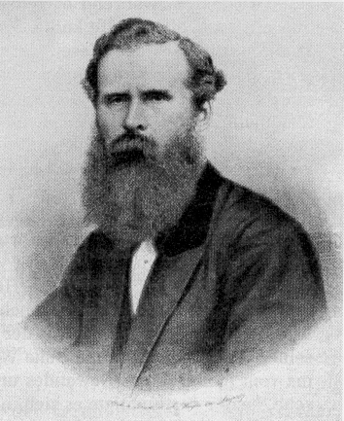

Image 8: Sir William Crookes (1832-1919)

He discovered the chemical element Thallium in 1862. He was elected as a member of the British Royal Society on the 4th of July 1863 in recognition of this discovery and later also knighted (1897). He became president of the Royal Society in 1913 and prior to that, president of the Society for Psychic Research between 1896 and 1899. Crookes became specifically well-known through his research into electrical gas discharges (the “Crookes tube” was named after him) and the invention of the radiometer. He is mentioned in all old and new books on physics.

Emerging from the USA, spiritism with all it mediumistic variants also began to spread throughout England from 1850 onwards. Numerous mediums displayed the most varied kind of astonishing processes. Public discussions took control over this theme and the press pounced on it. As it still happens these days, a large section of critics dismissed the whole things as being a fraud. They were now very pleased that an eminent scientist, namely Professor Crookes, was prepared to verify with scientific methods that this was not a fraud. The phrase: “Ubi Crookes, ibi lux” (Where Crookes is there is light, that is to say, clarity) was used up to that point. At the beginning of his investigations he also believed that these phenomena were either based on superstitions or at least on unexplained trickery. He wanted to find out.

From 1869 to 1875 Crookes visited and investigated a multitude of mediums. Some of them were, in chronological order: Daniel Dunglas Home (1833 – 1886), Kate Fox (1841 – 1892), Charles Edward Williams, Florence Cook (1856 – 1904) and Anni Eva Fay (an American medium). A further nine mediums are mentioned by name and others were mentioned but remained nameless.

His thorough examination of these mediums allowed Crookes to determine that the processes in question were not deceptions or slights of hand, but genuine natural events that could not be explained on hand of the existing laws of physics (even to this day). He writes about it:

“These experiments seemed to conclusively substantiate the existence of a ‘new energy” that is somehow and in an unknown way linked to the human organism and it could expediently be called ‘psychic energy’.”

Crookes held and defended this view to his death even though he was attacked in a most severe way by being called foolish and gullible.

From the comprehensive examinations Crookes undertook we will only concentrate on those that deal with the materialisation processes of medium Florence Cook (1856 – 1904). She first appeared in public with her psychic abilities in 1871 when she was not quite 15 years old. Due to telekinetic and materialisation processes taking place through her, she aroused quite a sensation in interested circles. Crookes became aware of her about a year and a half later and from the middle of December 1873, participated in his first meeting with her. Further meetings in 1874 were particularly carefully carried out over a period of nine month in his own flat. Florence intermittently lived with the Crookes family for this purpose and was therefore under constant control. Not only scientists and friends participated at these meeting, Mrs. Crookes and their adolescent children also participated. Florence Cook was therefore under constant observation by a lot of eyes. She didn’t have an opportunity to make any “preparations” and she was always thoroughly examined and often tied up or bound.

For three years, a phantom figure that called herself Katie King appeared as a constant companion at the side of Florence Cook. Crookes reports:

“I will for now bypass most of the tests Katie gave me at numerous opportunities when Miss Cook favoured me by holding meetings at my house and I will only describe one or two of the most recent ones. I have been experimenting for some time with a phosphor-lamp that consisted of either a 6 or an 8 ounce bottle that contained phosphoresced oil and that was tightly corked. I had reason to hope that some of the mysterious phenomena within the closet could be made visible with the light of this lamp and Katie also declared that she expected the same results.

After Katie had walked amongst us during the meeting on the 12th of March 1974 and had talked to us for some time, she retreated behind the curtain that separated my laboratory, my study room that also served as a closet at that time, from the room where people sat. She came back to the curtain after a minute, called me and said: ‘Come into the room and lift my medium’s head because it has slumped down.’ Katie stood in front of me dressed in her usual white garment and her turban-like headgear. I immediately went into the study room, passed Katie who stepped aside to allow me through, to see Miss Cook. I found Miss Cook has partially slipped off the couch and her head hung down at a completely twisted angle [similar to the image 10]. I lifter her back onto the couch and whilst doing this had the satisfying evidence that Miss Cook was not dressed in Katie’s costume, but that she wore her usual black velvet dress and that she was in a deep trance. Not more than three seconds would have passed between me seeing Katie standing on front of me dressed in white and me lifting Miss Cook back onto the couch from the position she had slumped to.

When I returned to my observation post near the curtain, Katie appeared once again and told me that she felt that she was now ready to show me herself and her medium at the same time. The gas [that is to say, the light in the form of the then common gas lamps] was turned off and she asked me to use one of my phosphor lamps. After she had shown herself to me in the phosphor lamp light for a few seconds, she handed it back to me saying: ‘Come inside and look at my medium’. I followed closely behind her into the study room and by the light of my lamp saw Miss Cook lying on the couch, exactly the way I had left her. I looked around for Katie, but she had disappeared. I called her, but I did not receive an answer.

Once I had returned to my seat, Katie also appeared very soon after and she told me that she had stood very close to Miss Cook the whole time. She then asked me whether she could try to undertake an experiment for me. After having taken my phosphor lamp from me, she went behind the curtain but she didn’t ask me have a look this time. She handed the lamp back to me after a few minutes and explained that she wasn’t successful because she had used up all her energy. She was however willing to try it another time. My oldest son, a 14 year old boy who had sat opposite me in such a way that he could see behind the curtain, explained to me that he had seen Miss Cook in the room with the phosphor lamp clearly hovering over her and illuminating her, but he had not seen anybody holding the lamp.”

Crookes ended his comprehensive report about his examinations from March 1874 as follows:

“Before I finalise this article I would like to mention a few points of difference I observed between Miss Cook and Katie. Katie’s height varies, I have seen her in my house six inches taller than Miss Cook. Last night, barefoot and not ‘standing on her tippy-toes’, Katie was only four and a half inches taller than Miss Cook. Katie’s neck was exposed last night and her skin, neck and face, was completely soft to touch and to view, whilst there was a large blister on Miss Cook’s neck that, under similar circumstances, was clearly visible and felt rough to the touch. Katie’s ears are not pierced whilst Miss Cook usually wears earrings. Katie hair is straw blonde whilst Miss Cook’s hair is dark brown. Katie’s fingers are much longer than Miss Cook’s and her face is also larger. There are also various deviations in her mannerism and the way she expresses herself.”

At the beginning of June 1874, Crookes once again touches upon the differences between phantom and medium by writing:

“After I have recently seen so much of Katie, whereby she was illuminated by electric light, I am now in a position to add a few more differences between her and the medium to the ones I mentioned in a previous article. I have the absolute certainty that Miss Cook and Katie are two separate individuals in as far as their bodies are concerned. A number of small marks on Miss Cook’s face are missing on Katie’s face. Miss Cook’s hair is so dark that it nearly borders on Black. A lock of hair from Katie, lying before me and having been cut from her luxuriant braids with her permission, after I traced them back to her scalp in order to convince myself that they actually grew from there, is of a very bright chestnut colour.

I counted Katie’s pulse one evening. It beat at a steady 75 times per minute, whilst Miss Cook’s beat was its usual cadence of 90 beats per minute a short time later. When I placed my ear close to Katie’s chest I could hear a rhythmic heartbeat within it that was actually pulsating far steadier than Miss Cook’s, when she allowed me to undertake a similar experiment after our session. This actually revealed that Katie’s lungs were far healthier than that of her medium, because Miss Cook was being treated by a doctor for a severe cough.”

Other observers beside Crookes have always emphasised that the medium and the ghostly apparition could not be identical.

Professor Crookes also utilised physical aids during his examinations of Florence Cook and he also consulted other pundits as he had done before with Daniel Dunglas Home. It was his friend and colleague Cromwell F. Varley in this case. The following experiment Varley and Crookes undertook was to not “secure” Florence in fetters, but to connect her body, from one arm to the other, to an electric circuit. As Varley had made a name for himself by inventing a process for finding breaks in electric cables, he was well versed in electric measuring techniques and he possessed, for his time, some very sensitive electrical gauges. In order to elucidate the subsequent article by Varley I would like to add the following: Image 9 shows the schematics of the test array. Two so-called Daniell-Elements with zinc and copper electrodes provided the required voltage and electrical source at 1.09 Volts each. The electrical gauge he used was a galvanometer G (a sensitive electrical current gauge), ergo a cable tester.

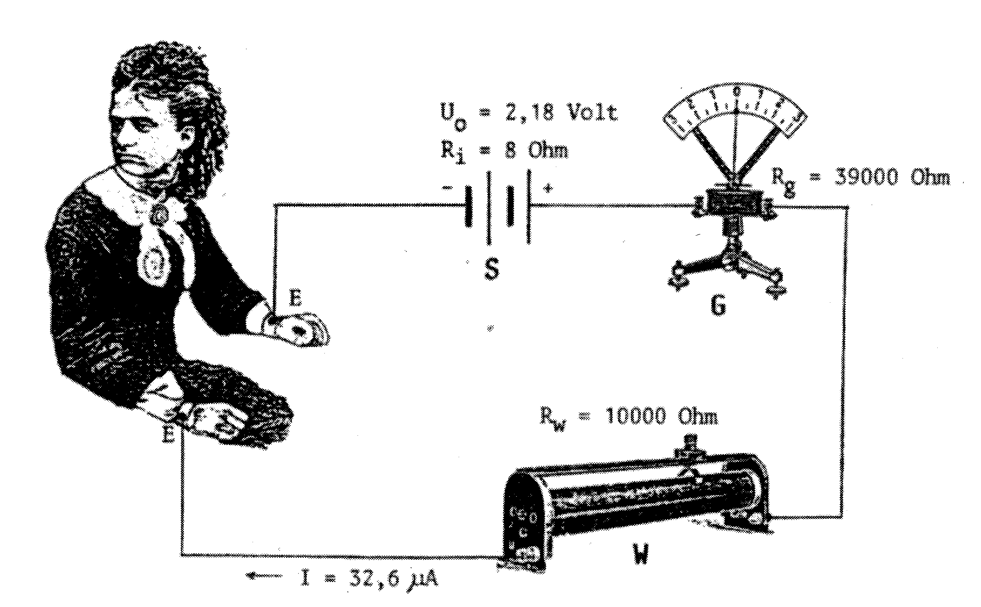
Image 9: Experimental array of Varley and Crookes in March 1874 in order to supervise the medium Florence Cook during a materialisation session where the spirit entity Katie King appeared.
E= Electrodes with gold coin, S = Source of Voltage, W = Series resistor (10 k/Ohm), G = Galvanometer.

If the medium had detached itself completely from the wires it was attached to at any time in order to be able to play the phantom Katie, the pointer deflection of the galvanometer would have immediately returned to zero. This was however never the case. Varley reports:

“The experiments in question were carried out at the home of justice of peace Mr. J. C. Luxmoore, J. P. at 16 Gloucester Square, Hydepark West, London. The backroom was separated from the front parlour with a heavy curtain in order to exclude the light coming from the parlour as the backroom was used as a dark-closet. The doors to the darkened room were locked after it had been searched prior to the meeting. The parlour was illuminated by a shaded paraffin lamp lit by a small flame. The galvanometer used for the experiment was placed on the mantelpiece ten or twelve feet from the curtain. The following observers were present: Mr. Luxmoore, Mr. William Crookes (Member of the Royal Society), Mrs. Crookes. Mrs. Cook, Mr. G. R. Tapp, Mr. Harrison (Editor of the ‘Spiritualist’) and myself. Mr. Crookes sat close to the curtain on one side whilst Mr. Luxmoor sat on the other side. Miss Cook sat in an armchair in the room that was later to be utilised as the dark-closet. Two sovereigns (English coins), with soldered platinum wires attached to them, were fastened with an elastic band to each arm just above the wrist…

Mr. W. H. Harrison, also present, wrote down the values Varley read from the instrument and also his own comments, he recorded them according to a timetable that Varley dictated from time to time. The current flowed from both elements via the galvanometer, through resistor W, Miss Cook and back to the battery. At 7pm, the resistance of the body of the medium effected a measure of 220 divisions on the scale of the galvanometer and when the two sovereigns completed the circuit, a deflection of 300 divisions was registered. The current was not switched off for one second during the session. If the circuit had been broken, the reading on the galvanometer would have moved by 200 divisions.

As the room was sparsely lit, my eyes were less sensitive than those of the other observers, because I spent most of the time intently looking at the brilliant, reflective mirror of the galvanometer.”

The phantom Katie King appeared soon after the medium had fallen into a trance and Varley reports about this:

“As I looked at Katie, the wick of the lamp was temporarily increased in order to give me a better view. Katie looked very much like the medium Miss Cook and I said to her: ’You look exactly like the medium’. She replied: ‘Yes, yes’. I was therefore very keen to see whether the movements of her hands and arms would cause some change to the intensity of the electrical current flowing through her. Such changes could be observed at times. At other opportunities, when she opened and closed her hand for instance or when she wrote something down, no changes to the voltage of the current showed up.

The room was darkened towards the end of the meeting and Katie allowed me to near her. She allowed me to take her hand. It was long, completely cold and sticky. Katie allowed me to enter the dark-closet a minute or two later in order to awaken Miss Cook from her trance. I found her still slumped in her armchair in a deep trance, her head was on her left shoulder and her right hand was hanging down. Her hand was small, warm and dry and not long, cold and damp like Katie’s.

She came out of her trance within two to three minutes whilst Mr. Luxmoore and Mr. Crookes entered with a light. The sovereigns, the blotting paper and the wires were exactly the way I had left them, namely attached to her arms with elastic bands.”

- This experiment shows that the medium could not have played the phantom Katie King, as opponents still maintain to this very day.

Photography also played a part in the research methods Professor Crookes applied to Florence Cook. The photos that were realised were important when it came to refuting often made objections that the participants at these meetings had fallen prey to hallucinations. Crookes reports:

“As I have of late participated at Miss Cook’s meetings to an excellent degree and as I have been relatively successful with taking numerous photographs of Katie King with the help of electric light, I believed that the publication of a few details could be of interest to the readers of the “Spiritualist’.

During the week, before Katie took her leave, she held meetings at my house almost every evening in order to give me the opportunity to photograph her under artificial light. Five properly equipped cameras were accordingly positioned for this purpose. One of the cameras contained a full-size plate, another a half-size plate and the third a quarter-size plate and the last two were stereoscopic cameras that were simultaneously and at every opportunity fixed on Katie when she allowed herself to be photographed. Five developing baths and five fixer baths were used and a lot of plates were cleansed ready to be reused so that no hindrance or delay could happen during the photographic sessions, sessions I carried out myself with the help of an assistant.

My study room was used as a dark-closet. It had French doors that opened into the laboratory; one half of these doors was lifted off its hinges and replaced with a curtain to make it easy for Katie to go in and out. Those amongst our friends that were present sat in the laboratory facing the curtain. The cameras were positioned somewhat behind them, ready to photograph Katie if she would appear and also to capture everything within the closet the moment the curtain was drawn for such a purpose. Three to four pictures were taken every evening and having five cameras at the ready, it produced at least 15 individual photos. Some of them got spoiled during the development process and some during the regulation of the intensity of the light. Altogether I possess 44 negatives, some of them are bad, some of them of moderate quality and some excellent.”

Professor Crookes did not publish any of his 44 negatives. Some of the pictures were however given to other participants at the meetings and they were published decades later from their property or their estate. A frequent participant at the meetings with Florence Cook, a Mr. W. H. Harrison, publisher of the journal “Spiritualist”, made magnesium-flash photos of Katie King. Some of them also found their way into other publications later. I render only two of these photos with image 10 and image 11. I reproduced a further eight from the book “Zeugnis für die jenseitige Welt”. Cookes research and other examinations show that temporary humanlike entities can develop from so-called “paranormal materialisations”, they can behave like normal human beings and the latter can touch, question and medically examine them.
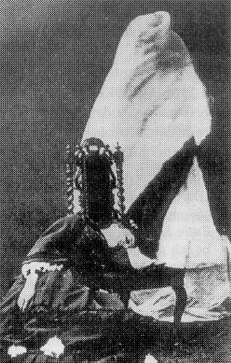
Image 10: (Right) Florence Cook in a trance with a materialised phantom figure behind her. The phantom is completely enveloped and probably still developing. This photo was taken by Professor Crookes in 1874.
Taken from: R. G. Medhurst/K.M. Goldney: William Crookes and the physical Phenomena of mediumship, P. 144, Plate 3.

Image 11: (Left) The phantom Katie King, taken by Professor Crookes in May 1874. Taken from: Four ‘Katie King’ Photographs, Plate 4
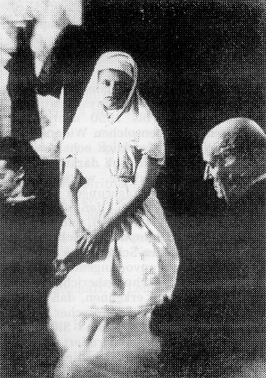
- Everything Crookes himself and his helpers (for instance B. Varley) observed has been so thoroughly examined by him that any deception by Florence Cook is completely out of the question.

One of his detractors, an English surveyor by the name of Trevor Hall also acknowledged this in 1960. But he decided to put immediate leverage on Professor Crookes just the same and asserted that Crookes, as impresario of the Florence-Cook-Séances, had perpetrated the swindle together with the medium. He also asserted that an adulterous affair exited between them and that the materialisation session served to disguise this fact. Crookes, her senior by 24 years, is supposed to have carried this out in his own residence of all places and in front of his whole family, numerous friends and her fiancé (as from the 29th of April 1874 her husband) and nobody was supposed to have noticed this “affair”? Besides, Crookes wasn’t present years earlier and later and the materialisation occurred just the same.

One could not invent his defamations more infamously if one tried, particularly as those concerned and their immediate witnesses died decades ago.

Trevor Hall’s accusations are however still disseminated and non-suspecting readers believe them. Who takes the time to thoroughly read the original literature these days? The method of imputing sexual misconduct has always been a convenient way to ruffle the credibility of a human being, all according to the motto: “Something will always stick”.

* * * * * * *

I n d e x:
(The translator is unaware of whether any of the books listed below are available in English)

Bozzano, Ernesto: Some 'Katie King' Materialisations. In: Quarterly Transactions of the British College of Psychic Science, Vol. XII, Jan. 1914, S. 263 – 265.

Crookes, William: Mr. Crookes noch kein Spiritualist. In: Psychische Studien, 1875, 218-219.

Crookes, W.: Researches in the Phenomena of Spiritualism. – London: Verlag J. Bums, 1874.

Crookes, W.: Notizen einer Untersuchung über die sogenannten spirituellen Erscheinungen während der Jahre 1870 – 73. In: Psychische Studien, 1874, H. 2, 53 - 59; H. 3, 104 – 109; H. 4, 155 – 160; H. 5, 208 – 287; zugleich Quarterly Journal of Science, Jan. 1874.

Crookes, W.: Das Photographieren einer psychischen Gestalt mittels elektrischen Lichtes. In: Psychische Studien; (1875) 1, 19 – 24; zugleich in: The Spiritualist, No. 93 vom 5. Juni 1874.

Crookes, W.: Die mutmaßlichen Geistergestalten und ihr fast positiver Beweis. In : Psychische Studien; (1874) 9, 385 – 389; zugleich in: The Spiritualist, No. 84 vom 3. April 1874.

Crookes, W.: Die Psychische Kraft und der moderne Spiritualismus. In: Psychische Studien, 1874, H. 4, 170 – 175; H. 6, 267 – 277; H. 7, 317 – 325.

Crookes, W.: Schreiben an den Herausgeber des 'Spiritualist', Mr. E. W. Allen, in London, über mutmaßliche Geister-Gestalten. In Psychische Studien; (1874) 7, 289 – 292; zugleich in: The Spiritualist, No. 76 vom 6. Febr. 1874.

Crookes, W.: Jahresrede als Präsident der British Association zu Bristol. In: Psychische Studien; (1898) 10, 481 – 488; zugleich in: Light, No. 922 vom 10. 9. 1898.

Crookes W.: Der Spiritualismus und die Wissenschaft. – Leipzig: Verlag Franz Wagner, 1872; Verlag Oswald Mutze, 1898.

Crookes, W.: Materialisationsversuche, hrsg. von R. Tischner. – Leipzig: Verlag Oswald Mutze, 1923

Edwards, Harry: The Mediumship of Jack Webber. – 3. Aufl. – London: Verlag Rider and Company, 1953.

Gerloff, H.: Die Phantome von Kopenhagen. Ein Bilderbuch. – Büdingen-Gettenbach: Verlag Welt und Wissen, 1958.

Grundwald, Fritz: Mediumismus: die physikalischen Erscheinungen des Okkultismus. – Berlin: Ullstein, 1925.

Marryat, Florence: There is no Death. – Philadelphia: Verlag David McKay, 1917.

Mattiesen, Emil: Das persönliche Überleben des Todes. 3 Bde. – Berlin: Verlag Walter de Gruyter, 1936 – 1939, Nachdruck 1962 und 1987.

Medhurst, R. G. / Goldney, K. M.: William Crookes and the physical Phenomena of Mediumship, Proceedings of the Society for Psychical Research, Col. 54, Part 195, March 1964, S. 25 – 157.

Schiebeler, Werner: Der Tod, die Brücke zu neuem Leben. – Melsbach / Neuwied: Verlag Die Silberschnur, 1988.

Schiebeler, W.: Zeugnis für die jenseitige Welt. – Melsbach / Neuwied: Verlag Die Silberschnur, 1989.

Schrenck-Notzing, Albert Frh. von.: Materialisationsphänomene. Ein Beitrag zur Erforschung der mediumistischen Teleplastie – 2., stark verm. Aufl. – München: Ernst Reinhardt, 1923.

Schrenck-Notzing, Albert Frh. von.: Der Kampf um die Materialisationsphänomene. – München: Ernst Reinhardt, 1914.

Varley, Cromwell Fleetwood: Erste experimentelle Prüfung der angeblichen Geister-Erscheinungen. In : Psychische Studien; (1874) 7, 342 – 349; zugleich in: The Spiritualist, No. 82 vom 20. 3. 1874.

o. V.: Summarisches über mutmaßliche Geister-Gestalten. In: Psychische Studien, (1874) 10, 433 – 442; zugleich in: The Spiritualist, No. 88 vom 1. 5. 1874.

o. V.: Die Abschiedssitzung des angeblichen Geistes Katie King. In: Psychische Studien; (1874) 11, 486 – 491; zugleich in: The Spiritualist, No. 92 vom 29. 5. 1874.

o. V.: Miss Cooks Mediumschaft. In: Psychische Studien; (1874) 8, 341 – 342; zugleich in: The Spiritualist, No. 82 vom 2. 3. 1874.

o. V.: Four 'Katie King' Photographs. In: Quaterly Transactions of the British College of Psychic Science, Vol. XIII, April 1934 to Jan. 1935, S. 25 – 30.

Schrenck-Notzing, A. Freiherr von: Materialisation Phenomena (1923), Preface
Schrenck-Notzing, A. Freiherr von: The Battle against the Materialisation Phenomena. A defence statement. – Munich: Ernst Reinhardt, 1914.
Einer Nielsen (8-12-1894 – 26-2-1965), for 50 years an important materialisation medium in Copenhagen. His psychic abilities started at age 17 as a trance medium. His first full-materialisation happened on the 1-9-1914. Nielsen was a commercial clerk and started his own small business, he trained to become a naturopath and functioned as a paranormal healer from then on.
Schrenck-Notzing, A Freiherr v: Materialisation Phenomena P. 529
Ders. ebd., plate 140 and 141 respectively image 216 and 217.
Ders. ebd. P. 528
Albumen: Important type of protein that constitutes more than 50% of the blood plasma.
Grunewald, Fritz: Mediumship (1925), P. 56
Ders., ebd., P. 58
Edwards, Harry: The Mediumship of Jack Webber (1953) P. 91.
Gerloff, Hans: Die Phantome von Kopenhagen. (1955) P. 109.
Schiebelr, Werner: Der Tod, die Brücke zu neuem Leben. (1988)
Schiebeler, Werner: Zeugnis für die jenseitige Welt. (1989)
Gerloff, Hans: Die Phantome von Kopenhagen. A picture book (1958), P. 64/65.
Gerloff, Hans: Die phantom von Kopenhagen (1955), P. 124.
Ders., ebd., P. 126f.
Crookes, William: Die Psychische Kraft und der modern Spiritualismus (1874), P. 323.
Ders., ebs., 272.
Medhurst, R. G. / Goldney, K. M.: Willian Crookes and the physical Phenomena of Mediumship (1964), P. 35. “These experiments seemed to conclusively substantiate the existence of a ‘new energy” that is somehow and in an unknown way linked to the human organism and it could expediently be called ‘psychic energy’.”²⁰
Crookes, William: Der Spiritualismus und die Wissenschaft (1872 / 1898), P. 47.
Crookes, William: Materialisationversuche (1923), P. 10. Ders.: Die mutmasslichen Geistergestalten und ihr fast positiver Beweis (1874). P. 386.
Ders., ebd., P. 389.
Crookes, William: Das Photographieren einer psychischen Gestalt mittels electrischen Lichtes (1875), 22; ders., : Materialismusversuche, P. 15.
Cromwell Fleetwood Varley: (1828-1883), eminent English physicist and electrical engineer, general engineer of the British International Telegraph Society, author of a number of works about underwater telegraphy, constructor of the second and successful transatlantic cable, inventor a numerous improvement to fault-finding underwater telegraphy technology, from 8-6-1871 member of the Royal Society. Details according to R. G.Medhurst/ K. M. Goldney; William Crookes and the physical Phenomena of Mediumship, P. 158 and C. F. Varley: Erste experimental Prüfing der angeblichen Geister-Erscheinungen, P. 342.
William Crookes: Materialisationsversuche, P. 17; C. F. Varley: Erste experimentelle Prüfung der angeblichen Geister-Erscheinungen, P. 342.
E. C. Varley: Erste experimentelle Prüfung der angeblichen Geister-Erscheinungen, P. 342.
W. Crookes: Materialisationversuche, P. 13.
Four ‘Katie King’ photographs (1934), P. 25 – 30.
W. Schiebeler: Evidence of an otherworldly world.

